Accessible PowerPoint 2016

Structure
- Add a Title for your file under the FILE tab, info. Locate the Properties section and there you will find a Title edit box. Add your title there.
- Check the language for your document. It should match the language you are using to write with. This is found under the FILE tab under More: Options.
- Set your slide layout with SLIDE MASTER.
  - In the View tab, location the master view and select the slide master view. Here you can make universal changes for Font size and type as well as font color. You can also select a color theme for your slide show.
  - If you want to create a custom slide for a brand theme, do this in slide master. Find the slide layout you want to use to the left and modify. Rename your layout to find it easily when you close Slide Master. To rename a layout, right click over the layout on the left column.
  - This is also where you can add place holders. If you modify an original slide layout, use the selection page to check the slide reading order.
    - Note: Inserting a text box on an individual slide is not read by a screen reader. To ensure your content will be read by a screen reader, insert the content in a place holder.

- When you create your slides, each slide must have a unique (different) TITLE in the Title Place Holder.
- If you do not want a title to appear, hide it with the eye icon found in the selection pane.
- When it is visible, the eye icon on the selection pane will be open. When it is hidden it will have a slash over the eye or a horizontal line in place of the eye, indicating it is closed.
Check each slide for the READING ORDER.
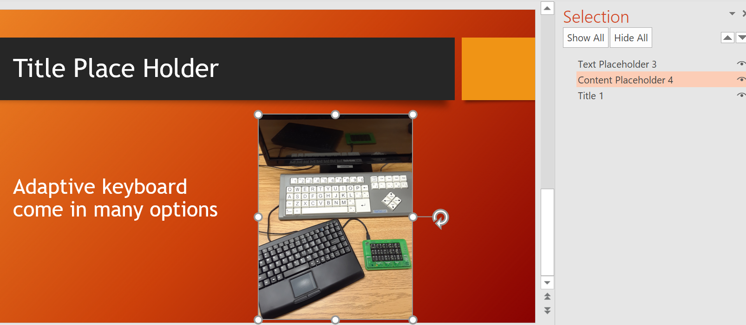
  - Microsoft offers a tool for this! Use the Selection Pane for all slides.

  - To get to the selection pane, use the Home tab and locate the Drawing tools. Select the Arrange options. At the bottom, find Selection Pane. It will open up to the right of your slide.

  - A screen reader reads the slide in a reading order from BOTTOM to TOP. A person with vision reads the slide top to bottom, left to right. So you want to make sure that the orders match. Start at the end of the selection pane reading order list. Move up and see if the reading order is correctly highlighted on the slide. If not, move the item in the selection pane to the correct order with the up and down arrows or click and drag.

Accessible Content and Design

Alternative Text
- All images, charts, tables, graphics need alternative text.
  - Most softwares show an Edit Alt Text options when you right click on the image. Or look on the toll bar for this options. Add a meaningful description explaining the photo as it is used in the presentation.
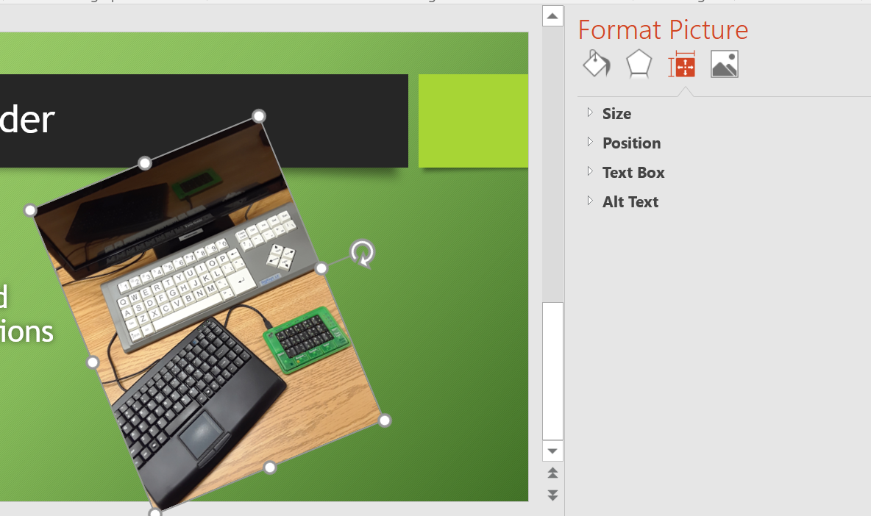 2016 version
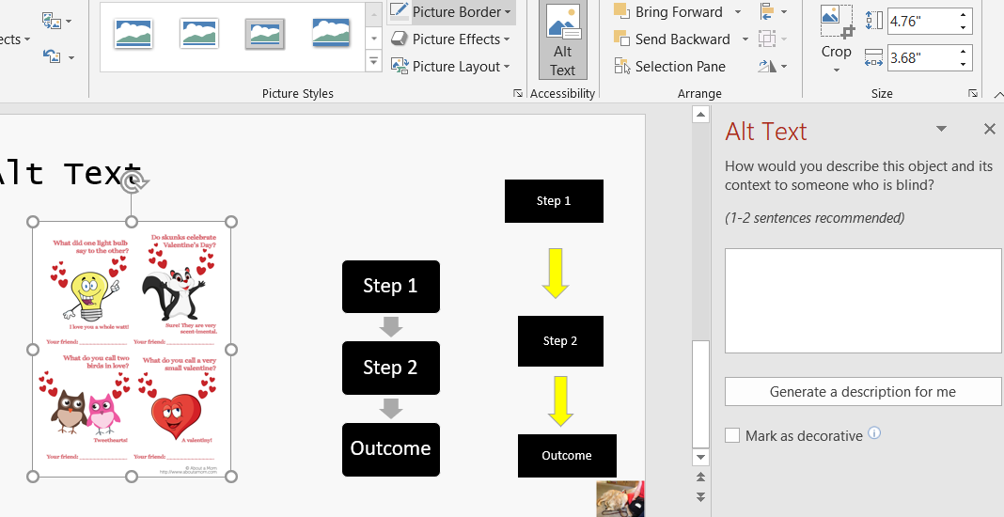 2019 version
  - For multiple images or graphics inserted separately outside of a place holder, if they create a group, use the grouping option.
    - Use the control key continuously as you select the objects to be included. Select the Home table, and under the drawing tools, select arrange. Next, select GROUP. Let go of the control key. All objects selected are grouped. Add Alternative text.
  - Meaningful descriptions are important for alternative text. Provide a description that explains the photo and what it means to the slide content or how it relates to the presentation points. If there is a lot to say, add details in the speaker notes section of the slide.

Videos
Any video that is shown during a presentation should be captioned. A video shown through the presenters YouTube account can be captioned using the YouTube captioning tools in the Studio video editing area. If using the auto captioning feature, be sure to edit for accuracy and correct spelling.
You can insert a video in PowerPoint. To make the video accessible, it must be captioned. With 2019 or greater versions, you can also caption the video. A separate hand out is available on this topic alone.

Web & Email Links
A PowerPoint file is both an electronic document as well as a printable, paper based visual training tool. By best practices, this area should consider the electronic document standards. For this reason, a web link should be attached to link text and be made into a hyper link.
- Link text should tell the reader where the link will take them.
- Insert the web link to the link text by highlighting the text and selecting the Insert tab, and then select Hyperlink. This opens a new window. You can edit the link text in the “text to display” box. Add the web link to the “address” box.
  - For the visual training resource, if the web link is short, consider adding it below the hyper link. If the link is long, consider using Bitly to create a shorter link and then add the Bitly link on the slide.

Use of Color
Ensure the colors chosen for the design offer enough contrast between the font and slide background to be seen. You can use a color contrast chart like the one below or use the The Paciello Group Colour Contrast Analyser.

Do not use color to identification an action or to identify multiple subjects.
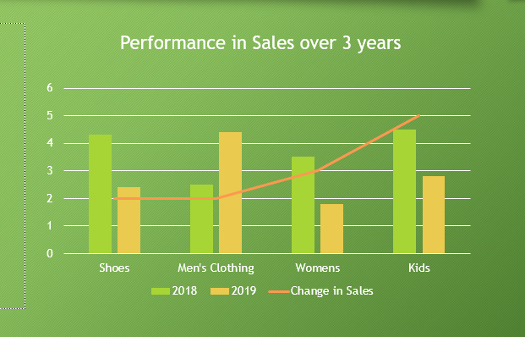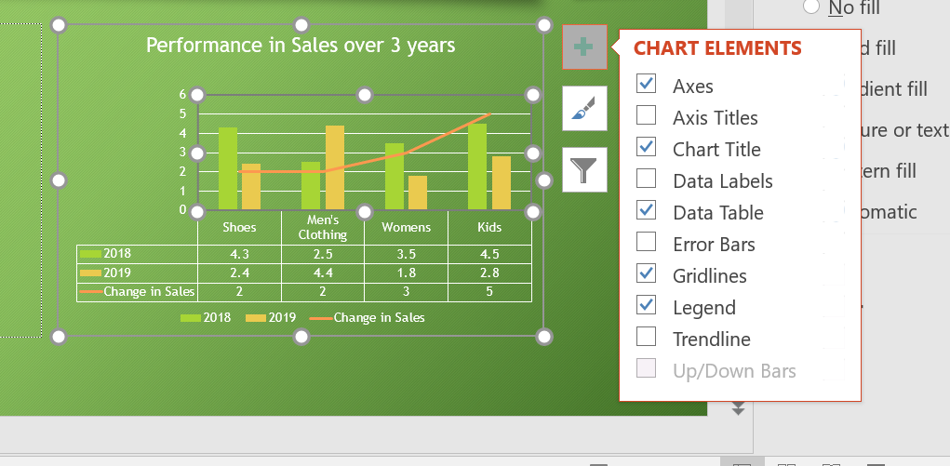
- Improve accessibility by adding descriptions to the chart. For example a Data Table.
- Since a chart is read as an image in PowerPoint, do not forget to add Alt text.

Built-In PowerPoint Tools
- The Accessibility Checker in PowerPoint will find errors with reading order, missing alt text, missing slide titles and so forth. Click on the page error to reveal where the fix is needed. Is some later versions, there is a drop down arrow to make the change easily.
- Selection Pane will find errors in reading orders on a slide that has been modified. Unlike the accessibility check that automatically runs through all slides, you use the Selection Pane manually on each slide.

Saving as a PDF
If you are saving the PPT file as a PDF, use the Save as Type function to select a PDF extension. There is more accessibility work to do in the PDF file, but know that you have transferred most of your accessibility work on the PPT file into the PDF file.

Resources
World Wide Web Consortium on accessible presentations
WebAIM on accessible PowerPoint
Microsoft on accessible PowerPoint
The Paciello Group Colour Contrast Analyser

The Department of Elementary and Secondary Education does not discriminate on the basis of race, color, religion, gender, gender identity, sexual orientation, national origin, age, veteran status, mental or physical disability, or any other basis prohibited by statute in its programs and activities. Inquiries related to department programs and to the location of services, activities, and facilities that are accessible by persons with disabilities may be directed to the Jefferson State Office Building, Director of Civil Rights Compliance and MOA Coordinator (Title VI/Title VII/Title IX/504/ADA/ADAAA/Age Act/GINA/USDA Title VI), 5th Floor, 205 Jefferson Street, P.O. Box 480, Jefferson City, MO 65102-0480; telephone number 573-526-4757 or TTY 800-735-2966; email civilrights@dese.mo.gov.

