Creating Accessible Social Page Posts
As of March 2021, these are Alt Text step by step instructions for Twitter, Facebook, Instagram and Pinterest. These platforms are always changing format, so check with their help section if you cannot locate what you are hoping to find on the platform you are posting to.

Image Alt Text for Twitter
Compose a Tweet in the Tweet edit box.
- Attach your photo(s).
- When photo loads, select edit. Select ALT.
- Add descriptive text to the photo in the edit box. (The limit is 1000 characters.)
- Click the SAVE button.
- You can add a description to each image in a Tweet.
- To post Tweet, Select TWEET.
Note: Image descriptions cannot be added to videos.
- When your Tweet is posted, there will be a small ALT icon noted on the image at the bottom left had corner.
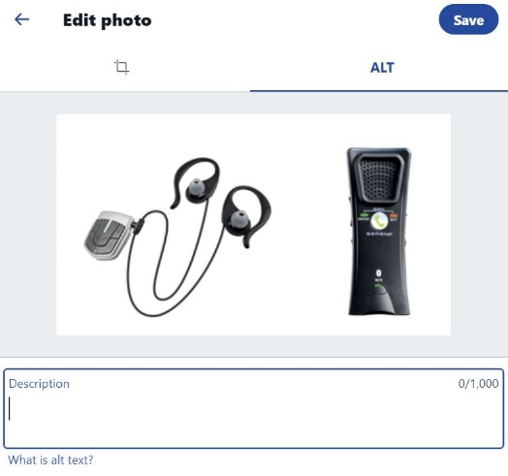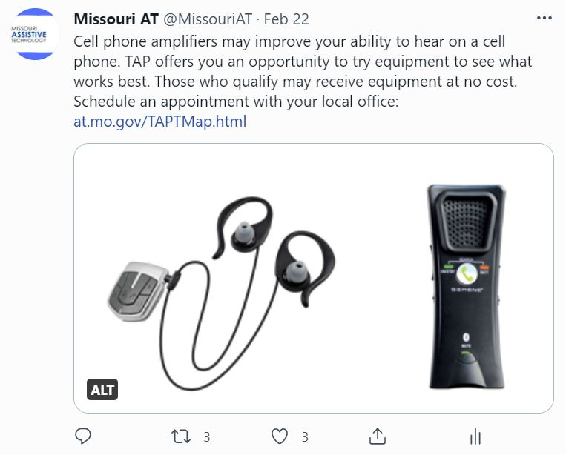

GIF Alt Text on Twitter
Compose a Tweet in the Tweet edit box.
- Attach a GIF.
- Select Add Description below the GIF image.
- Add descriptive text for the GIF in the edit box. (The limit is 1000 characters.)
- Click the SAVE button.
- To post Tweet, Select TWEET.

Image Alt Text for Pins on Pinterest
Add original image to pin by clicking the directional up arrow. If you select an image from the destination website for your pin, you cannot add Alternate text to their website image.
- On the right of the image locate the Add Alt Text button. Select Add alt Text.
- Add other details for the pin.
- Publish
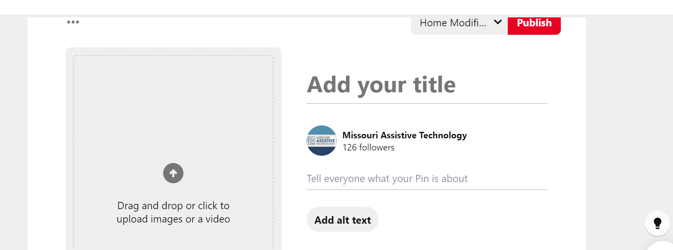

Image Alt Text for Facebook Posts
Facebook uses automatic alt text with object recognition technology to provide a visual description of a photo that can be read out loud by a screen reader. It is typically general and does not always meet expectations for a descriptive alt text, specific to your post. You can replace this text to provide a better description of your photo.

Create a new post
- To see and edit alt text for a photo before you post it:
- In a new post, click Photo/Video at the top of your News Feed.
- Select the photo you want to add.
- Hover over the photo and click Edit.
- The automatically generated text will be shown close to where you can add custom alt text. The layout can appear differently for a computer or smart device. Scroll down if you do not initially see this. It is already selected.
- Select the Custom Alt Text.
- Write your descriptive alt text in the box.
- To save your alt text, click Save in the bottom left.

Edit a posted image that is missing Alt Text
- To change the alt text of a photo after you've posted it:
- Click the photo to open it. (You may need to click on the post first, and then click on the photo.)
- Click in the top right and select Change Alt Text.
- Add alt text.
- Click Save.
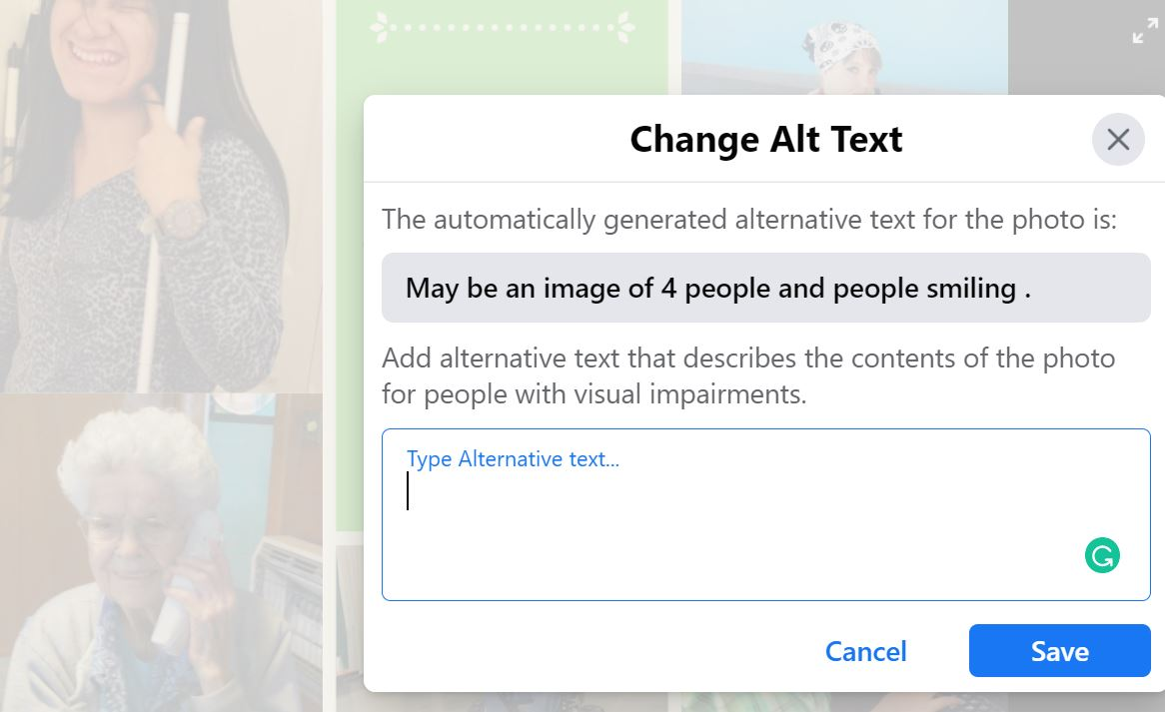

Image Alt Text for Instagram
On Instagram you can add alt text when composing a Feed post or after it is posted, in the edit mode.

Create new a feed post.
- Select image (Images) and edit as normal. Select Next.
- The next screen allows for the post text. Scroll down to the Advanced Settings.
- Select Advanced settings. Locate and select Write Alt Text.
- Add descriptive text in the edit box for each photo. Select the check mark when completed.
- Return to the post screen, backing out of Advanced Settings.
- Post your post.

Edit a posted image missing Alt Text
- Open the post.
- Locate the 3 dots at the top right corner and select them.
- A submenu opens. Select Edit.
- One the photo an Edit Alt Text appears. Select that.
- The next screen hold the edit box to add the descriptive alternative text.
- Select the check mark at the top when done and again on the edit screen.
- The alt text is stored in the photo now.

The Department of Elementary and Secondary Education does not discriminate on the basis of race, color, religion, gender, gender identity, sexual orientation, national origin, age, veteran status, mental or physical disability, or any other basis prohibited by statute in its programs and activities. Inquiries related to department programs and to the location of services, activities, and facilities that are accessible by persons with disabilities may be directed to the Jefferson State Office Building, Director of Civil Rights Compliance and MOA Coordinator (Title VI/Title VII/Title IX/504/ADA/ADAAA/Age Act/GINA/USDA Title VI), 5th Floor, 205 Jefferson Street, P.O. Box 480, Jefferson City, MO 65102-0480; telephone number 573-526-4757 or TTY 800-735-2966; email civilrights@dese.mo.gov.

