Captioning in YouTube

Here is how you start
- Start by uploading your video in your YouTube Studio.
- As its uploading, enter the video details.
  - Add a title, description and answer the question if this was a video made for kids.
  - Select the SHOW MORE option. For captioning set up you MUST have the language selected in the video details. It may be preselected for you.
- If you have the video transcript, in the next screen, select add Captions.
- If you will use auto-Generated captions, finish the set up and leave the video for about an hour or so. Check back later to see if auto captions are available.
- You are the creator, so any versions that say “Creator”, you have created that file. When it says Automatic, which is what YouTube has generated. It is also not published for your audience.
- It is only published if it says Published: Creator.
- You should also see a CC icon showing under your video on your channel, indicating the captions are visible.

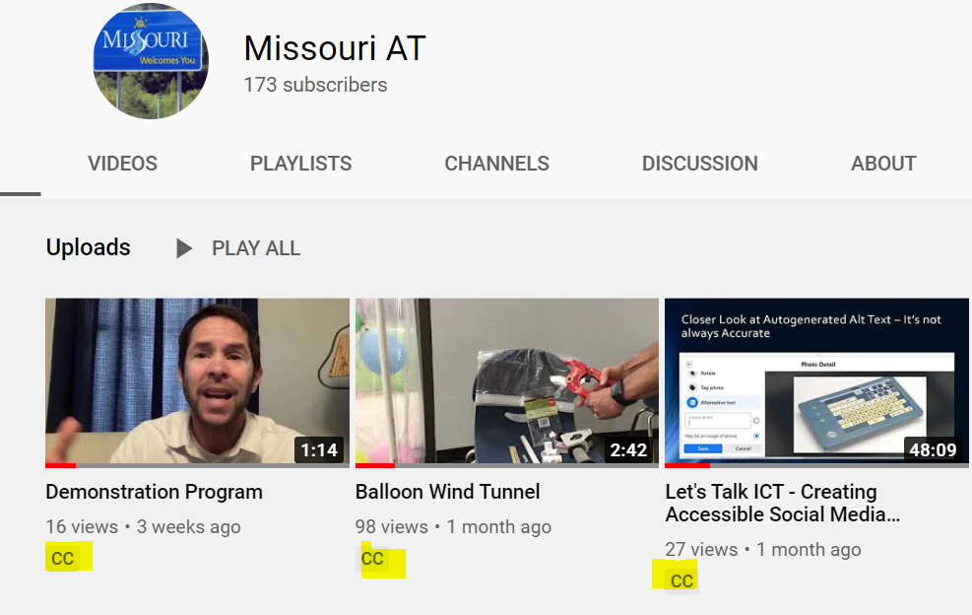

- Auto captioning does not provide proper punctuation or proper capitalization. It could miss spell a name, an industry term, or product name. So proof read your transcript. It would also not identify multiple speakers.

- You can edit in the text box. You can also copy and paste your caption transcript into a Google Doc. Use the Find and replace feature for repetitive corrections.
  - The personal reference I is usually spelled with a small “i”.
- Copy and paste your edited version in Google Docs, back into the YouTube transcript edit box.
  - Examples of editing needs:
    - Identify each speaker.
    - Describe atmosphere sounds.
    - Capitalize names.
    - Correct misspellings.
    - Optional: Add punctuation.
- Play the video alongside of the text box. Review the content for accuracy. Notice any atmosphere sounds.
- Next, select the link for edit timing. Review the transcript for timing. Make those corrections. (Normally, YouTube gets the timing right with the exception in the Note below.)
- If complete, publish.
- Note: if you need to edit the video such as cut out a section, do this before uploading to YouTube with another video editing program. Otherwise the timing in your video captioning is off set and you will need to manually adjust it

Download the YouTube Caption Transcript File
In the subtitle edit list, select the 3 dots next to the automatic publishing version and select download. You can chose the file format you desire.
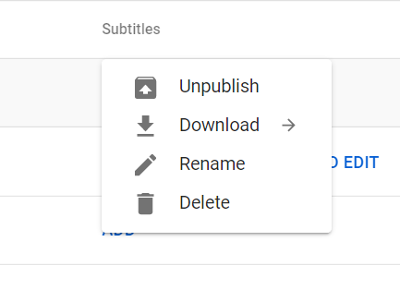
- To download a file for a Facebook post, select an SRT file.
  - For Facebook the file must de saved as:
    - Save this file is this specific format: Filename.en_US (filename DOT Language abbreviation UNDERSCORE country abbreviation)
- To download a file for a PowerPoint video, select vtt file.
  - For a PowerPoint file, the file must be saved as:
    - Save as a plain text file: NAME.en.vtt (The first part of the name (NAME) can be what you chose. The later part (en.vtt) lets the video player know to write the captioning in English.

DIY Captioning Points
The difference between auto captioning and manual captioning can be seen in the punctuation as well as identifying who is speaking, if there is more than one speaker. People that use captioning see the difference.
Atmosphere sounds need to be captured. If they exist in your video, caption them. Examples: (Dog barks), (Giggles and laughing). Auto caption will not catch these sounds, so you will most likely need to add them in.

The Department of Elementary and Secondary Education does not discriminate on the basis of race, color, religion, gender, gender identity, sexual orientation, national origin, age, veteran status, mental or physical disability, or any other basis prohibited by statute in its programs and activities. Inquiries related to department programs and to the location of services, activities, and facilities that are accessible by persons with disabilities may be directed to the Jefferson State Office Building, Director of Civil Rights Compliance and MOA Coordinator (Title VI/Title VII/Title IX/504/ADA/ADAAA/Age Act/GINA/USDA Title VI), 5th Floor, 205 Jefferson Street, P.O. Box 480, Jefferson City, MO 65102-0480; telephone number 573-526-4757 or TTY 800-735-2966; email civilrights@dese.mo.gov.

