Becoming a Proficient AAC User:

AAC and Autism Spectrum Disorder

AAC=  Augmentative and Alternative Communication  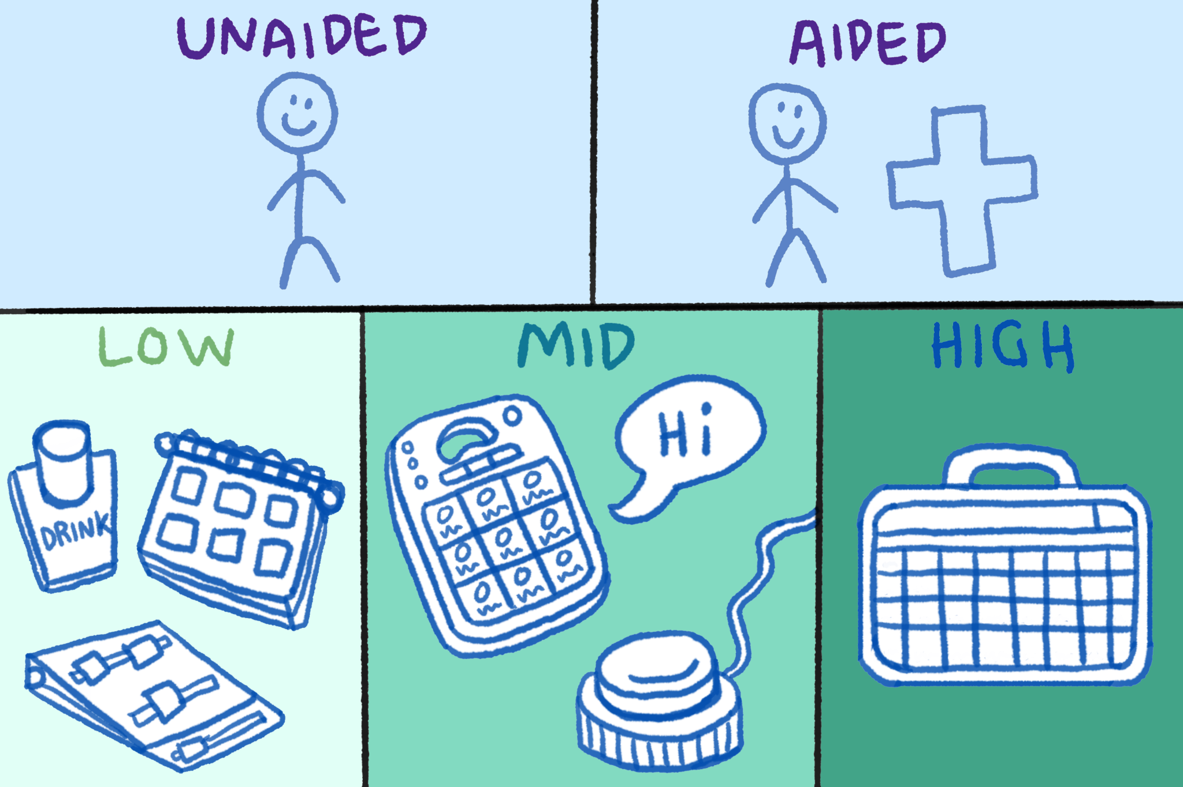  My AAC Features and Tips:  SNUG Building a message word-by-word: - encourages segmentation of language - allows for growth - flexible Speech Output Having the device speak each word as message is constructed: - gives sensory feedback - makes it easier to participate in conversation It’s important for me to have a “fast” voice!  Sensory Everyone has different sensory needs. Settings and colors on the device can be changed to accommodate personal preferences and needs. Motor Planning When word locations are unique and consistent, the physical process of communication becomes automatic.  My AAC User Skills:  - control device functions such as volume  - edit their device  - advocate for themselves | Autism Spectrum Disorder:  ASD is a developmental disorder that causes repetitive behaviors and communication deficits.  Communication:  Difficulty with:  - Participating in conversation  - Understanding social “rules”  - Understanding non-literal language  - Reading body language and facial expressions  - Making eye contact  Restrictive and Repetitive Behavior:  - Insistence on sameness and routine  - Repetitive movement and activities  - Intense interests  - Different sensory processing  People with ASD experience these traits in different ways and to different degrees of severity.  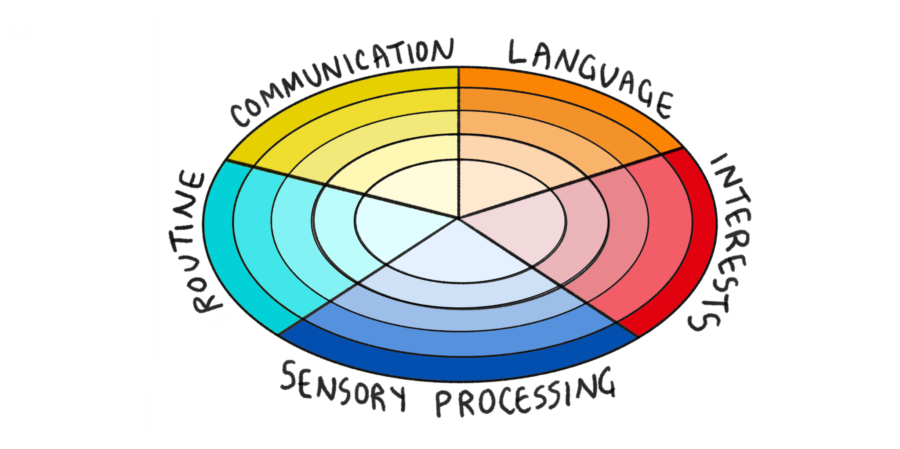  Level 1: requiring support  Level 2: requiring substantial support  Level 3: requiring very substantial support  25-30% of people with ASD cannot meet their communication needs through speech alone.  (Brignell, A., Chenausky, K. V., Song, H., Zhu, J., Suo, C., & Morgan, A. T. (2018)  Possible reasons:  - Apraxia  - Sensory Processing Disorder  - Difficulty with receptive language

Citations
ASHA. (2021). Augmentative and Alternative Communication (AAC). American Speech-Language-Hearing Association.
ASHA. (2015). Introduction to AAC. American Speech-Language-Hearing Association.
McNaughton, D., & Light, J. (2013). The iPad and Mobile Technology Revolution: Benefits and challenges for individuals who require augmentative and alternative communication. Augmentative and Alternative Communication, 29(2), 107–116.
NIH. (2014). Autism Spectrum Disorder. National Institute of Mental Health.
CDC. (2022, November 2). Diagnostic Criteria for 299.00 Autism Spectrum Disorder. Centers for Disease Control and Prevention.
CDC. (2023, April 4). Data & Statistics on Autism Spectrum Disorder. Centers for Disease Control and Prevention.
Brignell, A., Chenausky, K. V., Song, H., Zhu, J., Suo, C., & Morgan, A. T. (2018). Communication interventions for autism spectrum disorder in minimally verbal children. Cochrane Database of Systematic Reviews, 2018(11).
Tierney C, Mayes S, Lohs SR, Black A, Gisin E, Veglia M. How Valid Is the Checklist for Autism Spectrum Disorder When a Child Has Apraxia of Speech? J Dev Behav Pediatr. 2015 Oct;36(8):569-74. doi: 10.1097/DBP.0000000000000189. PMID: 26114615.
Patten E, Ausderau KK, Watson LR, Baranek GT. Sensory Response Patterns in Nonverbal Children with ASD. Autism Res Treat. 2013;2013:436286. doi: 10.1155/2013/436286. Epub 2013 Jul 15. PMID: 23956859; PMCID: PMC3727194.
Boddaert N, Chabane N, Belin P, Bourgeois M, Royer V, Barthelemy C, Mouren-Simeoni MC, Philippe A, Brunelle F, Samson Y, Zilbovicius M. Perception of complex sounds in autism: abnormal auditory cortical processing in children. Am J Psychiatry. 2004 Nov;161(11):2117-20. doi: 10.1176/appi.ajp.161.11.2117. PMID: 15514415.
Minshawi NF, Hurwitz S, Fodstad JC, Biebl S, Morriss DH, McDougle CJ. The association between self-injurious behaviors and autism spectrum disorders. Psychol Res Behav Manag. 2014 Apr 12;7:125-36. doi: 10.2147/PRBM.S44635. PMID: 24748827; PMCID: PMC3990505.
Stanborough, R. J. (2021, November 19). Autism Masking: To Blend or Not to Blend. Healthline.
Grandin, T. (2022). Frequently Asked Questions. Temple Grandin Ph.D.
Semantic Compaction Systems. (2009). A Comparison of Language Representation Methods. Australia; Liberator.
PRC-Saltillo. (2019). About Minspeak. Minspeak Academy.
Hill, K. (2014). Achieving Success in AAC: Assessment and Intervention. Pittsburgh, PA; AAC Institute.
Friedman, V. (2024, January 19). How to design for autistic people - smart interface design patterns. Smart Interface Design Patterns RSS.
The Center for AAC and Autism. (2019). Components of Lamp. The Center for AAC & Autism.

