Popular 3D Printing Software:

Design
- TinkerCad, Blender, Fusion

Slicers
- Cura, Pursa

Steps to Printing a 3D Model

- Design or download your model (STL file).
- Open your slicer and “slice the print.” This will give you a gcode file.
- Add the gcode file to your memory card.
- Put the memory card in the printer, and heat up.
- For PLA Filament, I have the nozzle at 200℃ and the hotbed at 60℃.
- After the printer is heated up, start your print!
- Note: Purge lines and skirt will print first (Depending on settings)

Tips When 3D Printing
- Increase the temperature for smaller prints to help them stick to the hotbed.
  - Adding a brim, raft, or skirt to the print can also help a smaller print stick to the bed.
- Any oil, dust, etc. on the hotbed can cause prints to come unstuck…
  - Clean bed with dawn and hot, hot water once a week (helps prints stick)
  - Wipe down the hotbed with rubbing alcohol and a cotton ball after each print (helps print stick)
- Save your failed prints and other filament scraps to melt down in the oven into silicone molds to make other manipulatives
- Use acrylic paint markers and Mod Podge sealer to add color and protection to your prints

Places to get 3D Models
- Paths to Literacy General Link
- Round Table 3D Printing Link
- TacTiles 3D Printing for VI:
  - O&M Crossings
  - School Yard
  - Shape Tower Game
- Thingiverse 3D Designs for Physical Objects
- Braille and Large Print Services 3D
- Braille and Print Blocks
- 3D Printing Braille

- Perkins School for the Blind
  - 3 D printing
  - Printing models
- 3D Models Donated

- 3D Models Databases (collections of all types of 3D models)
  - You Magazine
  - Thingiverse
  - Yeggi
  - Printables
  - Cults3d
  - My mini factory
  - Pinshape
- Assistive Writing/Drawing Guide
  - model 753450
- Models of the Eyes
  - model 381790
  - Thing:2833672
  - Thing:3117478

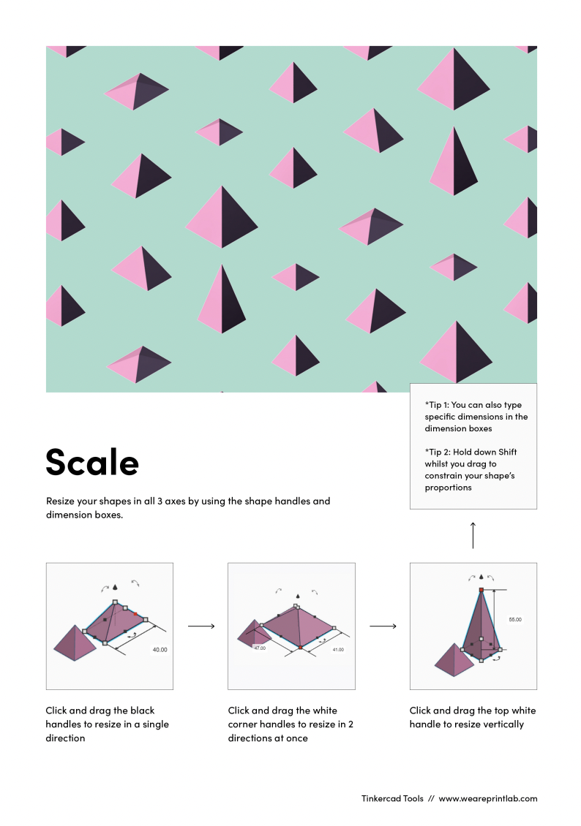
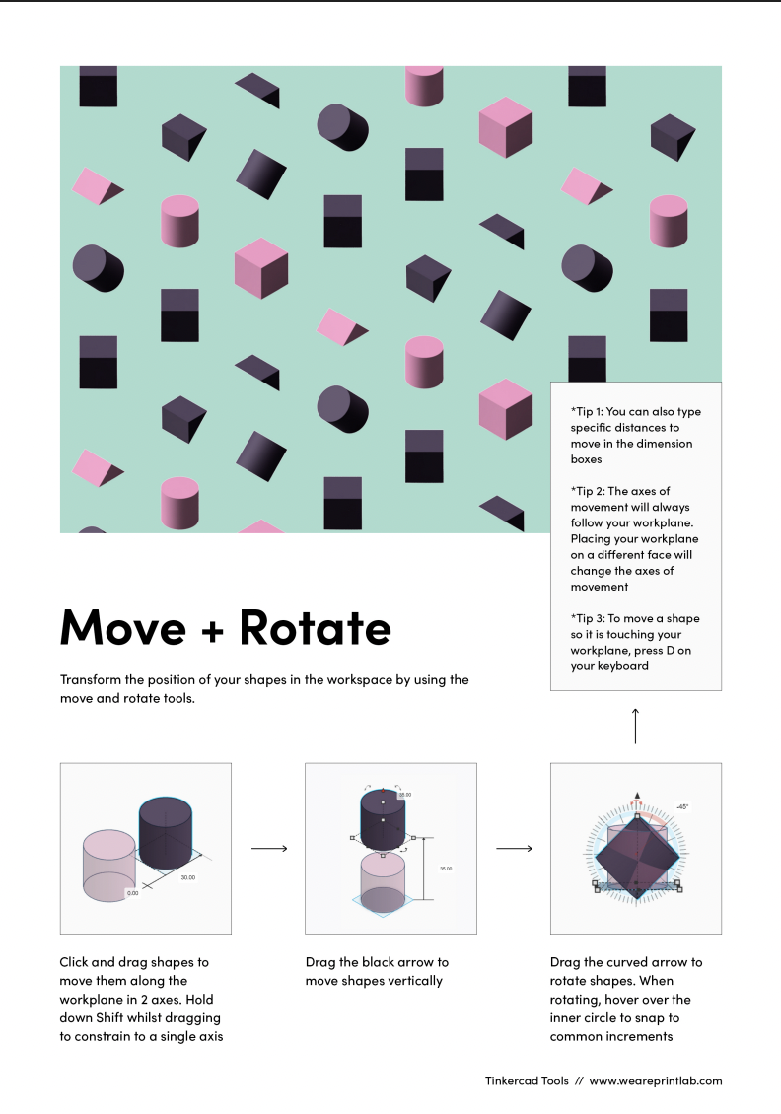
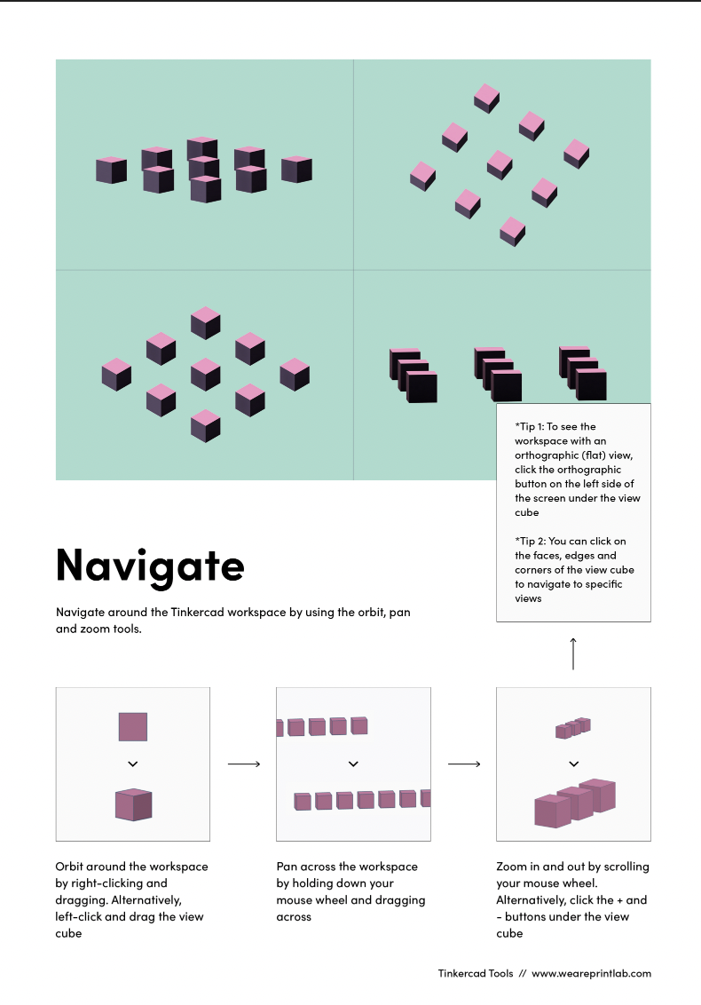
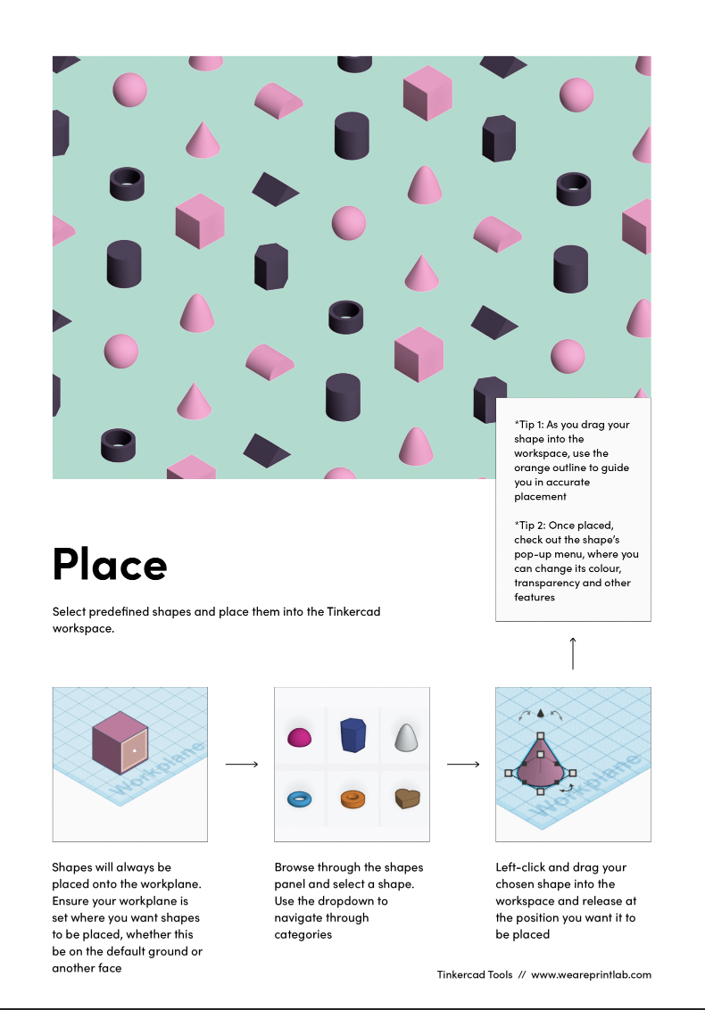
TinkerCad Helpful Hints
