Core List of Computer Adaptive Equipment

# Output Adaptations -

# Screen Readers for VI:

## JAWS Screen Reader

<http://www.freedomscientific.com/Support/TechnicalSupport>

Top technical questions about JAWS for Windows

## Computer screen with JAWS menu.

## Window-Eyes Screen Reader

<http://www.gwmicro.com/Audio_Video_Archive/Window-Eyes_Tutorials/>



## Text-to-Speech for LD:

## Read:Outloud

<http://donjohnston.com/readoutloud/>

rol6  
 A simple-to-use and affordable text reader, that makes it easy for you to provide access to any book file, to understand the content for a reader. (not full computer navigation capability like a screen reader software)

## Kurzweil 3000

[http://www.kurzweiledu.com/products_k3000win.asp](http://www.kurzweiledu.com/products.asp)

Designed for sighted users who have difficulty reading. Converts printed material into speech with scan feature. Highlights words as they are read.

## Read & Write Gold – Mobile

<https://www.enablemart.com/read-write-gold>

  Read &Write Gold supports struggling readers and writers, those with literacy difficulties (including dyslexia), through a host of reading, writing and study/research features. Enablemart website has a quick start guide and training manual.

### WYNN Wizard

<http://www2.freedomscientific.com/LSG/products/wynn.asp>



# WYNN program reads text aloud while highlighting spoken words, include the four color-coded toolbars, and provide reading, writing, studying, productivity, and Internet features. Website includes tip sheets.

# Output Adaptations – Magnification

## ZoomText (for PC or Mac)

<http://www.aisquared.com/index.htm>

[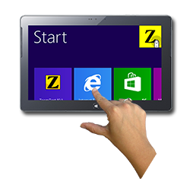](http://www.aisquared.com/zoomtext/)

Magnification features plus powerful, easy-to-use document reader.

Speaks all on-screen text, including menus, dialog boxes and controls.

Reads characters, words and lines of text by simply moving the cursor.

## MAGic Magnification

# <http://www.freedomscientific.com/Products/LowVision/MAGic>

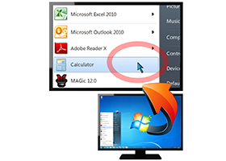46 magnification levels from 1x to 36x

MAGic's high-definition mouse and cursor enhancement options

Eliminate glare and increase contrast with built-in color enhancements

Speech options add human-sounding voices to speak text and echo user actions

Built-in training tools

Works well on computers where JAWS is installed

# Input Adaptations –

# Alternative Keyboards:

## Refreshable Braille Display (only for qualified Braille users – no training provided)

<http://www.freedomscientific.com/Products/Blindness/Focus40BrailleDisplay>

<http://hims-inc.com/products/braille-edge-40/>

[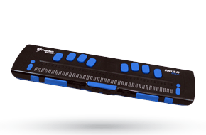](http://www.freedomscientific.com/Products/Blindness/Focus40BrailleDisplay)Focus 40 (by Freedom Scientific) **OR** Braille Edge 40 (by HIMS) 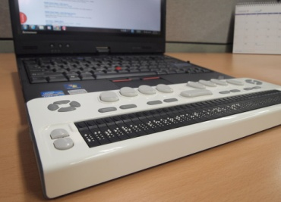

Both: Translates screen data into 8-dot refreshable Braille, 40-cell display, USB and Bluetooth connectivity.

Braille Edge has included applications for Notepad, scheduler, alarm, clock, calculator, stop watch, and countdown timer; also included SD card storage slot for up to 32GB of storage.

## Big Keys LX or Big Keys Plus

<https://www.enablemart.com/computer-accessibility/keyboards/large-print-and-large-key-keyboards/bigkeys-lx>

[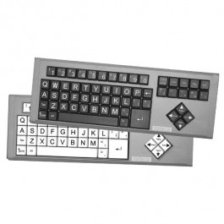](https://ds5cvxtqu2rt0.cloudfront.net/media/catalog/product/cache/3/image/700x700/17f82f742ffe127f42dca9de82fb58b1/l/x/lx-both-large.jpg)Option of black keys, white keys, or multi-color keys (Qwerty or ABC order)

## IntelliKeys Classic and USB

https://www.enablemart.com/intellikeys-usb

Intelligent, alternative keyboard that plugs into any Macintosh or Windows computer.

### Change the way IntelliKeys looks and functions by changing overlays

Six standard overlays featuring large, well-spaced keys in high contrast colors

Customize overlay settings such as the response or repeat rate

Convenient and flexible switch interface

## Large Print Keyboards (Keys-U-See, or Zoomtext keyboard or MAGic keyboard or MAC large print keyboard)

[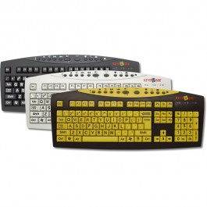](https://ds5cvxtqu2rt0.cloudfront.net/media/catalog/product/cache/3/image/700x700/17f82f742ffe127f42dca9de82fb58b1/k/u/kus2007_all.jpg)Zoomtext and MAGic keyboards compliment their respective magnification software programs. For individuals who just need the large print keyboard, other less expensive options such as the Keys-U-See keyboard are available. Zoomtext options - choose yellow keys with black letters, or black keys with white letters. MAGic only comes with black keys with white letters. Keys-U-See and MAC keyboard options – yellow, black, or white keys.

## Onscreen Keyboards (Wivik, OnScreen, SofType)

<https://www.enablemart.com/onscreen>[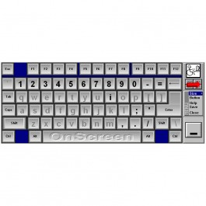](https://ds5cvxtqu2rt0.cloudfront.net/media/catalog/product/cache/3/image/700x700/17f82f742ffe127f42dca9de82fb58b1/o/n/onscreenkeyboard.jpg)

“OnScreen” - Complete keyboard emulation

Floats above windows; when minimized, appears as an icon in window bar

Word Predictor: predicts words from your writing patterns and customizable dictionary

Adjustable keyboard size

Adjustable key size

Dwell Selection: hover over the selected key and it will click for you

Multiple layouts: alphabetical, qwerty, Dvorak, or build your own (over 45 keyboards built-in)

***Other options: Wireless Keyboard (for physical access), one-handed compact keyboards***

# Input Adaptations –

# Alternative Pointing Devices:

***Expert Mouse Pro (Expert Trackball)***

<https://www.enablemart.com/expert-mouse-trackball>

[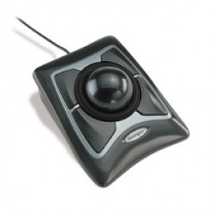](https://ds5cvxtqu2rt0.cloudfront.net/media/catalog/product/cache/3/image/700x700/17f82f742ffe127f42dca9de82fb58b1/k/e/kensington-expert-mouse.jpg)

Four programmable mouse buttons to handle repetitive mouse tasks such as double click or drag lock with a single click.

DiamondEye Optical tracking for superior accuracy

Award-winning Scroll Ring for precise fingertip scrolling

Large ball for maximum precision and control

Detachable wrist rest cradles hand in comfort

## Roller II Joystick

<https://www.enablemart.com/roller-ii-joystick>

[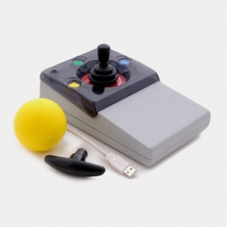](https://ds5cvxtqu2rt0.cloudfront.net/media/catalog/product/cache/3/image/700x700/17f82f742ffe127f42dca9de82fb58b1/r/o/roller-ii-joystick-ball-_-t-bar-no-logo.jpg)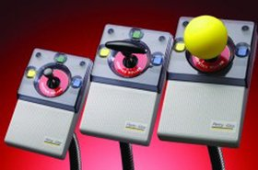Separate buttons support left and right click, double click, drag lock, horizontal and vertical lock and cursor speed control.

Flashing light indicates the drag button has been activated.

Available keyguard to help users isolate on the buttons.

Comes with two different input needs, T-Bar and Soft Sponge Ball.

Switches can be easily connected to emulate the mouse buttons with the Roller Plus Switch Box (sold separately).

## Roller Plus Joystick

<https://www.enablemart.com/roller-plus-joystick>

[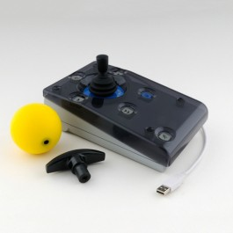](https://ds5cvxtqu2rt0.cloudfront.net/media/catalog/product/cache/3/image/700x700/17f82f742ffe127f42dca9de82fb58b1/t/r/traxsys-roller-plus-joystick.jpg)The Roller Plus Joystick has the same functions as a trackball, but cursor movement is achieved by moving the joystick rather than rolling the trackball. Certain users find this easier, particularly those with more severe motor impairments.

Six buttons support left and right click, double click, drag lock, horizontal and vertical lock, and cursor speed control. A flashing light indicates the drag button has been activated. All of the switches on the front panel, with the exception of the speed control, can be duplicated with remote switches.

Includes three handle options to accommodate the user’s needs: standard handle, T-Bar, and soft sponge ball. The removable keyguard helps locate the correct switch, support the hand, and avoid pressing wrong keys. Switches can be easily connected to emulate the mouse buttons with the included switch adapter box.

***Switches for computer access – Jellybean (2.5”), Big Red (5”)***

<https://www.enablemart.com/jelly-bean-twist-switch>

<https://www.enablemart.com/big-red-twist-switch>

[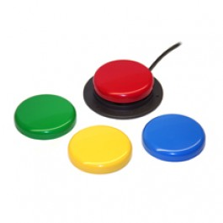](https://ds5cvxtqu2rt0.cloudfront.net/media/catalog/product/cache/3/image/700x700/17f82f742ffe127f42dca9de82fb58b1/j/e/jelly-bean-twist.jpg)

## HeadMouse Extreme

<https://www.enablemart.com/headmouse-extreme-bundle>

[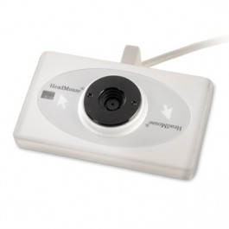](https://ds5cvxtqu2rt0.cloudfront.net/media/catalog/product/cache/3/image/700x700/17f82f742ffe127f42dca9de82fb58b1/d/v/dvx_500119.jpg)[https://ds5cvxtqu2rt0.cloudfront.net/media/catalog/product/cache/3/thumbnail/56x/9df78eab33525d08d6e5fb8d27136e95/h/e/headmouseoncomputer-large.jpg](https://ds5cvxtqu2rt0.cloudfront.net/media/catalog/product/cache/3/image/700x700/17f82f742ffe127f42dca9de82fb58b1/h/e/headmouseoncomputer-large.jpg)

HeadMouse replaces the standard computer mouse for people who cannot use or have limited use of their hands when controlling a computer. The HeadMouse Extreme emulates a USB computer mouse so no special software is required for operations – plug & play. The bundle comes with an onscreen keyboard.

## SmartNav with on-screen keyboard

<http://www.naturalpoint.com/smartnav/>

Smart-Nav AT mouse alternative gives you hands free control of a computer cursor.

Mouse clicks can be accomplished through a built in dwell clicking program or external switches.

Included with Smart-Nav AT is an on-screen keyboard for hands free keyboarding.

***Tobii PC Eye Go***

<http://www.tobii.com/en/assistive-technology/north-america/products/hardware/pceye/>

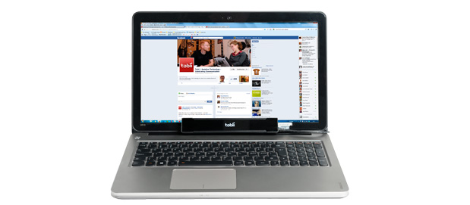

The Tobii PCEye is a peripheral eye tracker that attaches to a standard computer and enhances computer accessibility with the speed, power and accuracy of gaze interaction. The device replaces the standard mouse, allowing you to navigate and control a desktop or laptop computer using only your eyes.

## Input Adaptation –

**Keyboard Adaptations:**

**Co:Writer**

<http://donjohnston.com/cowriter-7/>

**Intellitools Classroom Suite**

<https://www.enablemart.com/intellitools-classroom-suite>

**Word Q/Speak Q bundle**

<https://www.enablemart.com/wordq-speakq-bundle-1>

**Write:Outloud**

<http://donjohnston.com/writeoutloud/>

## Input Adaptation -

## Voice Recognition:

## Dragon Naturally Speaking (Premium for PC, Wireless for PC, Dragon Dictate for MAC)

<http://www.nuance.com/dragon/index.htm>

[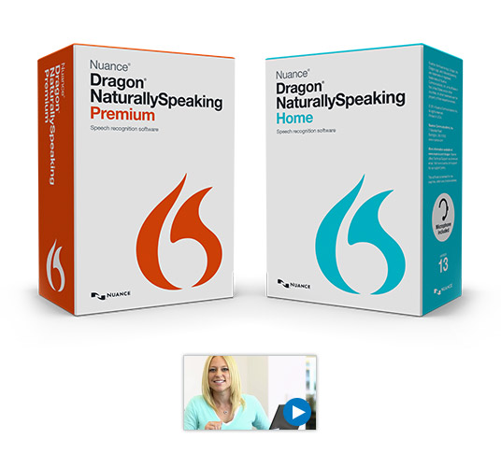](http://www.youtube.com/watch_popup?v=uXXvJ-4Abbc)

Talk and your computer types.

Revise, edit and format text.

Manage e-mail by voice.

Customize vocabulary.

Quick correct list.

Switch between applications.

## Andrea Electronics Array Microphone

<http://shop.andreaelectronics.com/pure-audio-usb-sa-with-free-array-2sa/>

