Do They Know What You Are Talking About?
Slides
Do They Know What You Are Talking About? 3
Introduction: (Slide 1) 3
Can you read this? (Slide 2) 3
Notes: 3
Autumn’s Story (Slide 3) 3
Notes: 3
Declaration of Independence (Slide 4) 4
Notes: 4
Autumn’s Story Continued (Slide 5) 4
Notes: 4
What is Plain Language? (Slide 6) 5
Notes: 5
Quote (Slide 7) 6
Why is it Important? (Slide 8) 6
Notes: 6
Words Matter (Slide 9) 7
Notes: 7
Terms and Conditions (Slide 10) 7
Notes: 8
Ballots (Slide 11) 8
Notes: 8
Forms (Slide 12) 9
Notes: 9
Core Principles (Slide 13) 9
Notes: 9
Common Techniques (Slide 14) 10
Notes: 10
Fun Facts (Slide 15) 10
Notes: 11
In Action– Paragraphs/Sentences (Slide 16) 11
Notes: 11
In Action– Jargon (Slide 17) 12
In Action– Familiar Words (Slide 18) 12
Notes: 12
In Action– Keeping it Simple (Slide 19) 13
Notes: 13
Tools and Resources (Slide 20) 14
Notes: 14
Jargon or Not to Jargon (Slide 21) 14
Notes: 14
Summary (Slide 22) 15
Notes: 15
Next Steps (Slide 23) 15
Notes: 15
Resources (Slide 24) 16

Do They Know What You Are Talking About?
By Tori Chance
April 2026

Introduction: (Slide 1)
Welcome everyone and thank you for joining me today. My name is Tori Chance, and my goal is to make you as passionate about plain language as I am. In doing so, we are going to talk about plain language, what it is, why it matters, and how we can apply it in our daily work to improve clarity and understanding. Hopefully, by the end of our session, you will have some practical tools you can begin using right away.

Can you read this? (Slide 2)
- R348s o;ious. Fs ubs dnatno stdrvs8tu5 ta3f ilfvos,epdm ft lej4v, fr osoed fr osrv dopmestiv sr osoe plevosel wlefolsid.
- Words matter. If you cannot understand what information is given, it makes it more difficult to make informed decisions.
Notes:
The first bullet shows gibberish that demonstrates how hard it can be for some people to read or understand information out of context.

Autumn’s Story (Slide 3)
- Learning disability in reading comprehension
- Original source documents

Notes:
This is my daughter Autumn. When she was in high-school in the early 2000’s, she began having difficulties getting her class work done. Her teachers, especially in American History, were asking her to read original source documents, like the Declaration of Independence, The Magna Carta, and The Constitution. Not the re-written in today’s language, but the ones that were written in British English, in cursive, 250 plus years ago.

Declaration of Independence (Slide 4)
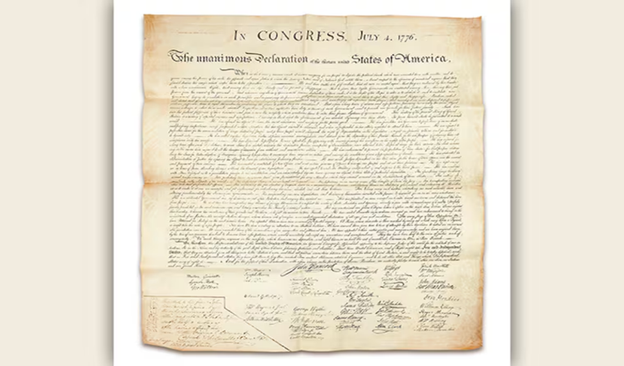
This slide showed an image of the original declaration of Independence.

Notes:
As you see, this is hard to read. If you look closer, you can see the sentence structure is completely different than our modern style. Additionally, the words are not well known or easy to understand.
Example: “The actual Enumeration shall be made within three Years after the first Meeting of the Congress of the United States, and within every subsequent Term of ten Years, in such Manner as they shall by Law direct.”
Plain language: “The first official population count must happen within three years after Congress first meets. Then, every ten years after that, the population must be counted again. Congress will choose the specific way to conduct each of these censuses.”

Autumn’s Story Continued (Slide 5)
- Learning disability in reading comprehension
- Original source documents
- Failing grades
- Finding documents in plain language
- Graduating with honors

Notes:
At the time, Autumn was struggling to read on grade level but did not qualify for an IEP. She struggled during the first semester of that year and almost failed. At first, we didn’t know how to help here, then I learned about the concept of plain language. I went to the Special Education teacher in our school and asked them for help with resources. They directed me to texts that had been modified to present the information in plain language with an explanation about what the context meant.
It turns out that providing the information in plain language was a life saver. The relief to her was immediate - she not only began to do better, but she in fact excelled from that point on. We did this for all her high school assignments, and she graduated with honors.

What is Plain Language? (Slide 6)
- Communication people understand the first time
- Focuses on clarity, simplicity, and structure
- Helps readers find, understand, and use information
  - Uses Familiar Words
  - No Jargon
  - 6 to 8th grade reading level
Notes:
Plain language isn’t about “dumbing down” information, it is about making sure your message is clear and accessible. The goal is for your audience to find what they need and understand it quickly without extra effort.
The focus of plain language is to make sure that your communication is clear, direct, simple and organized in an efficient structure.
Without clear communication, your audience will not be able to find or use the information you are creating.
Research suggests that some of the items that cause issues with understanding written or spoken communication comes from the information being written in jargon or advanced vocabulary that not all people have been exposed to.
Plain language means using familiar words and not industry specific terms or Jargon, writing clear sentences, presenting in an organized manner, and is written in between 6th and 8th grade reading so that most of the public can understand the words.
We will talk more specifically about what all of this means as we go through our presentation.

Quote (Slide 7)
“A communication is in plain language if its wording, structure, and design are so clear that the intended audience can easily find what they need, understand what they find, and use that information.”
- Source: International Plain Language Federation

Why is it Important? (Slide 8)
- Removes Barriers
- Easier to Use
- Gives Better Access
- Saves Time
- Builds Trust
- Is more Transparent

Notes:
Using plain language benefits everyone. It reduces confusion and makes our communication more efficient. It also supports accessibility standards, ensuring all audiences – including people with different backgrounds or reading levels- can understand our content.
Plain language removes barriers for people with cognitive/intellectual disabilities, low literacy levels, or those for whom the language is not their first language. It helps the audience find, understand, and use the information. This allows them to follow instructions, fill out forms, make decisions, and access services without frustration. Plain language reduces the time spent explaining, prevents mistakes. Because the language is clear, it builds trust with the user and is more transparent.
When you write or speak using plain language you ensure that information is immediately understood, accessible to a wide audience, and will be in general more helpful, providing better feedback and results.

Words Matter (Slide 9)
- Choose words carefully
  - Is it culturally appropriate?
  - Can they read it?

Notes:
While reading through resources I found a quote that I think speaks directly about why we must write for our audience.
“Words are the most basic building blocks of written and spoken communication. While there is generally no problem with being expressive, . . . People do not curl up in front of the fire with a federal regulation to have a relaxing read” - (From Digital.gov – linked in the resources)
Are your words culturally appropriate? One of my favorite examples of this is the difference between a lift and an elevator. They are the same thing, but if I am talking to an audience in the United States, it might be more appropriate to use the word elevator and if I were in England, it might be more appropriate to use the word lift.

Terms and Conditions (Slide 10)
This is a binding legal agreement (“Agreement”) between You and Phone Company America, Inc. and its past, present, and future parents, subsidiaries, affiliates, and related entities (both domestic and foreign), as well as all of their respective officers, agents, employees, representatives, predecessors in interest, successors, and assigns (“Phone C”). Please review the Agreement carefully. It affects Your rights. Electronic acceptance of the Agreement, opening the Product packaging, use of the Product, or continued possession of the Product constitutes acceptance of this Agreement regardless of whether You are the original purchaser, user, or other recipient of the Product. You agree that all users or other recipients of the Product are subject to and agree to be bound by the Agreement. If You are the parent or guardian of a minor user or recipient of the Product, you agree to the Agreement on their behalf. You may elect to opt out of arbitration within thirty (30) days of Your purchase or first activation (including activation of the Product by someone on Your behalf) of the Product, as set forth in Section 7 below. In the event of a conflict between the Agreement and any other applicable terms with Phone C, the Agreement shall govern.

Notes:
This is a paragraph of a phone company’s terms and conditions. There are more than 60 pages to the “Dispute Resolution Agreement” that these words were pulled from.
How many of you understand what this paragraph means?
How many of you read all the information in your terms and condition agreements for your phones?
Why not?
What would make it better?

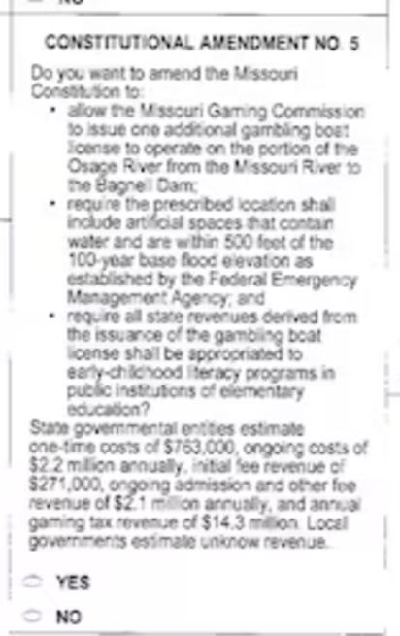
Ballots (Slide 11)
Constitutional Amendment No. 5
Do you want to amend the Missouri constitution to:
- Allow the Missouri Gaming Commission to issue one additional gambling boat license to operate on the portion of the Osage River from the Missouri River to the Bagnell Dam,
- Require the prescribed location shall include artificial spaces that contain water and are within 500 feet of the 100-year base flood elevation as established by the Federal Emergency Management Agency; and
- Require all state revenues derived from the issuance of the gambling boat license shall be appropriated to early-childhood literacy programs in public institutions of elementary education?

Notes:
The text above is from the Proposed Constitutional Amendment Number 5 on a Missouri Ballot. Ballots are another area where plain language is very important to making reasonably well-informed decisions.
How many of you have read ballot measures other than the one here and were confused about what they meant?
How many of you remember this proposed amendment to the Missouri Constitution?
How many of you understood how the funds flow was going to work?
How many of you wondered if it was a new “type/location” of license or just one license for one operation?

Forms (Slide 12)
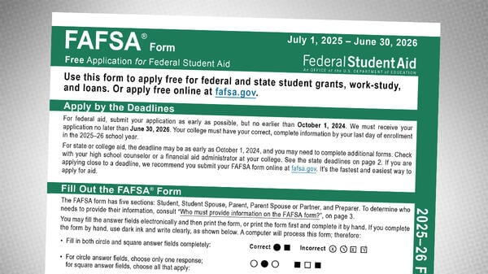
Notes:
This slide has an image of the Free Application for Federal Student Aid (FASFA).
How many of you have filled one of these out?
Did you find it easy to use?
Did you get frustrated?

Core Principles (Slide 13)
- Know your audience
- Use clear, familiar words
- Use reading levels between 6th and 8th grade
- Keep sentences short
- Organize information logically
- Leave white space
- Use active voice
Notes:
From the examples above, we can see how frustrating navigating everyday life can be if the information we need is not written in plain language. Let's talk about how to create using plain language.
The foundations of plain language are:
Knowing your audience. Who they are, what they need, and what they already understand.
If writing for a general audience aim to write between a 6th and 8th grade reading level.
Use clear, familiar words instead of technical language/jargon.
Keep sentences short and focus on one idea at a time.
Organize information in a logical order.
Leave white space so it is easier for focus on the words.
Use active voice because it keeps sentences clear and direct.

Common Techniques (Slide 14)
- Break long paragraphs into small chunks
- Use heading and bullet points
- Replace jargon or explain it
- Put key messages first

Notes:
There are some simple changes that can make a big difference.
First. Along with using short sentences, break long paragraphs into smaller chunks. This helps the reader absorb information.
Headings and bullet points guide the eye and make the content easier to skim.
Replace jargon or define it if you must use it. Jargon is very specific and readers outside of your workplace may not understand what the word is supposed to mean.
And always put your most important message first. This makes sure that your audience gets the main point before they lose interest.

Fun Facts (Slide 15)
- In 2000 average human attention span was 12 seconds
- In 2013 average human attention span was 8 seconds
- The Average attention span of a goldfish is 8 seconds
Notes:
The average human attention span in 2000 was 12 seconds. In 2013 it was 8 seconds. That means that we have less attention span than a goldfish. Less than a goldfish! That is not a lot of time for someone to read through or list to an idea or information, process it, and either act or respond. The information we present must be able to capture their attention and be easy to understand. Using plain language does that.
Given that, how many of you have received an email or a piece of mail this week that you didn’t understand what was in it? Did it make you mad or frustrated? That is how most of our population feels when they try to work with government sites, legal documents, health insurance and number of other ways they receive information.

In Action– Paragraphs/Sentences (Slide 16)
- In the event that an employee is unable to attend the scheduled training, they are required to submit notification in writing no less than 72 hours prior to the session.
- If you can’t attend the training, let us know in writing at least 72 hours before the session.
- The President shall, at stated times, receive for his services, a compensation, which shall neither be increased nor diminished during the period for which he shall have been elected.
- The President gets a set salary, and that amount cannot be raised or lowered during the President’s current term.
Notes:
Let’s look at plain language in action.
“In the event that an employee is unable to attend the scheduled training, they are required to submit notification in writing no less than 72 hours prior to the session. “
“If you can’t attend the training, let us know in writing at least 72 hours before the session. “
The original sentence is long and formal. Readers may need to slow down to understand it. The second version says the same thing in fewer words and talks directly to the reader. This shows how clarity improves without removing any meaning.
Let’s look at another example:
This one goes back to Autumn’s story and comes from the constitution. “The President shall, at stated Times, receive for his services, a compensation, which shall neither be increased nor diminished during the period for which he shall have been elected.“
We again see that this is long and formal. It also uses words that are not easily understood.
If we re-write it to say: “The President gets a set salary, and that amount cannot be raised or lowered during the President’s current term.” It becomes much clearer.

In Action– Jargon (Slide 17)
- The system’s authentication module utilizes a multi-factor verification protocol to validate user credentials prior to granting access to restricted resources.
  - Uses Jargon
- The system checks a user’s identity in more than one way before allowing them to access protected information.
  - Better Written for Plain Language
- Let’s circle back on this after we’ve aligned with the broader team.
  - Uses Jargon
- Let’s talk about this again after we check with the rest of the team.
  - Better Written for Plain Language

In Action– Familiar Words (Slide 18)
- The organization’s strategic initiative aims to optimize cross-departmental collaboration by implementing a comprehensive communication framework. – Using too many unknown words.
- The company wants teams to work better together by using a clear and simple communication plan. – Better Written for Plain Language
Notes:
Let’s look at familiar and grade level wording.
“The organization’s strategic initiative aims to optimize cross-departmental collaboration by implementing a comprehensive communication framework.”
This sentence is postsecondary in reading level, long, and complex. It also uses some business jargon.
The next sentence is shorter, uses more familiar words and is on a reading level between 6th and 8th grade.
“The company wants teams to work better together by using a clear and simple communication plan.”

In Action– Keeping it Simple (Slide 19)
- They were totally trying to obfuscate that conversation.
- They were trying to make it hard to understand.
- Total Disclosure of all facts is very important to make sure we draw up a total and completely accurate picture of the Agency’s financial position.
- Disclosing all facts is important to creating an accurate picture of the Agency’s financial position.
Notes:
Let’s look at using modifiers and unnecessary words.
“They were totally trying to obfuscate that conversation.”
In our first example we have a word that not many people understand as well as a modifier.
“The were trying to make it hard to understand.”
The next sentence is much easier to read.
Let’s try again.
“Total Disclosure of all facts is very important to make sure we draw up a total and completely accurate picture of the Agency’s financial position.”
Hard to read, but probably something that we would run across in business documents.
“Disclosing all facts is important to creating an accurate picture of the Agency’s financial position.”
This one says the same thing but is much easier to understand.

Tools and Resources (Slide 20)
- Readability checkers (Flesch-Kincaid, Hemingway, Copilot)
- Plain Language guidelines and checklists
- Organizational templates
- Style and formatting guides
- Let’s Practice
- Plain Language Practice
Employees are requested to adhere to the established guidelines for expense reporting to ensure timely processing.

Notes:
We don’t have to do this by ourselves; there are tools and resources available.
Readability tools can flag long sentences and complex words. Microsoft Word uses the Flesch-Kincaid scale for readability and has an editor that can help you rewrite your sentences. Hemingway and Grammarly, and Copilot can also do this.
Using templates and checklists help keep content consistent and many can be found online to help you create your own.
Using organizational style guides ensures that documents across the workplace look and sound unified.

Jargon or Not to Jargon (Slide 21)
- Level Set
- Goal
- Drill down
- Talk
- Pain points
- Fix

Notes:
Let’s look at some words that we hear daily in our working environment.
Raise your hand if you think it, is Jargon.
Level Set – Jargon
Goal – Not Jargon
Drill down – Jargon
Talk – not Jargon
Pain Points – Jargon
Fix – not Jargon

Summary (Slide 22)
- Plain language improves clarity and understanding
- Focus on your audience
- Use simple words, short sentences, and clear structure
- Tools can help refine your writing

Notes:
Plain language is about making communication easier for everyone. It helps people understand information faster and more accurately.
We can all improve clarity by keeping the audience in mind, simplifying where possible, and structuring information in a reader-friendly way. It is a small investment, with a big payoff.

Next Steps (Slide 23)
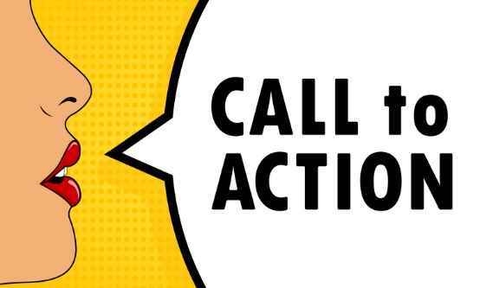
- Use plain language in emails, documents, and presentations
- Review existing materials for clarity
- Share tips with your coworkers
- Everyone deserves to understand the information they encounter

Notes:
Your next steps are to keep plain language in mind when you are writing emails, documents and giving presentations. Review existing materials for clarity and share tips with your coworkers.
In the end we use plain language, because everyone deserves to understand the information they encounter.

Resources (Slide 24)
- MoAT: Missouri Assistive Technology
- Principles of plain language
- Rhonda Weiss Center for Accessible IDEA Data
- CDC Health Literacy: Plain Language Materials and Resources
- Center for Plain Language Tools
- Federal Plain Language Guidelines
- USDA Plain Language Training Resources
- National Institutes of Health: Plain Language: getting Started or Brushing Up
- Maryland’s Clear Writing and Plain Language Checklist

