**Dragon Professional Individual**

## Orientation

* How to install Dragon
* The software is already installed on the ETC laptop.
* Set up a voice profile
  + Click on Dragon shortcut on the desk top
  + On the first time, Select NEW in the User Profile pop up box.
  + Follow prompts.
  + Complete the short reading section to allow Dragon to learn your voice.
  + Ensure the Dragon Extension is downloaded in Goggle Chrome.
* Getting started:
  + Upon opening the Dragon, select your profile (Previously set up.)
  + A prompt may ask for a microphone selection.
  + Use the USB headset provided.
  + The Dragon tool bar will appear at the top.
    - Red microphone icon = Microphone is off.
    - Green microphone icon = Microphone is on.
    - Blue microphone icon = Microphone is asleep and ready.
  + Dragon is voice command operated. Practice using these commands below in Google Chrome or Microsoft Edge.

## Basic dragon commands to read a Web Page

### Two main microphone commands:

* To turn on Dragon speak, “Wake Up”
* To turn off Dragon speak, “Go to sleep” or “Microphone off”

### Command sayings:

* To open a Browser =“Open Google Chrome”
* “Open Address bar = “Spell out URL”
* To activate a selection = “Press enter”
* To erase a dictated error = “Scratch that”
* To move from action items = “Tab”
* Activate a choice on the web in a list = “Click” or “Select”
* Move up a web page in sections= “Page Up”
* Move down a web page in sections = “Page Down”
* To move through a drop down list = “Go up (or down) # times”
* To move thru content = “Mouse Grid”
  + Say # in Grid where your selection is. Repeat until it is accurate to locating your content.
  + Once a number matches the mark, say “MARK”

## Key Features to Know:

* Dragon needs to get to know the user. So you need to train it to understand your voice. Plan on spending some time for this set up of your account. Open the Dragon shortcut on the desk top. It will open a User profile. If you created one, open yours. If not you need to create one.
* When speaking, be natural and smooth. Pause around commands.
* Your Dragon vocabulary is stored and a word can be trained to be understood if initially unrecognized.
* Besides normal active link focus indicators, Dragon will show the URL at the bottom left corner. To the bottom right, it will display the command it has heard.

## Disabilities Impacted

* Limited mobility in the hands, upper arm weakness, fatigue, or paraplegic.

## AT Testing Instructions

| **Website Elements to Test** | **Device Instructions** |
| --- | --- |
| Navigate to interactive elements (Focus indicator must be active) | Say “Wake Up” Say “OPEN Internet Explorer (or Microsoft Edge or Google Chrome).” Say “Go to the address bar” spell out URL and say “Press Enter”.  Browse webpage: speak “Page Up” or “Page down.”  Back button command: Speak “Go back” “Open new tab” “Switch to previous tab” “Switch to next tab” “Close tab”   * Another option to open tabs are “Press control 1” (First tab), “Press Control 2” (Second tab”, etc.   Close a tab, “Press Control W. To reopen last closed tab, “Press control shift” |
| Link | Test the reading order of links. Say Tab to have it move across the page. Or count the number of elements until a link and say Tab # times.  To enter the content of the page, use the Tab key command to find Skip to Main Content Element and say “Press Enter” |
| Button and Check box | To choose an input field, Speak “Click.”  “Tab” to next action |
| Select Lists Drop down (Example scheduling a trip) | Speak “Tab.” You will speak this until the focus indicator is where you want to work. Use Commands “Go up (or down) # lines”, “press Enter” to move through options and make selections. |
| Move through page | Mouse Grid. Say the “#”. The mouse grid narrows the field and offers new numbers. Say the “#”. It will narrow the mouse grid further. Once the grid number is on the mark, Do not say “#” instead, say “MARK” |
| Autocomplete | On a browser tab, Speak “Go to address bar” Speak “URL address” Speak “Enter” (If auto complete is on, it should show up here.  Once page is refreshed to URL address, speak “Page down” or “Page Up” |
| Scroll | Speak “Start scrolling down” “Stop Scrolling” |

## Resource Video

[Start at 3:17](https://youtu.be/G2m0kUkYHuQ) Part 2 [Dragon Naturally Speaking Tutorial](https://youtu.be/FUdSstbfTak)

[My RSI Life channel](https://www.youtube.com/playlist?list=PLREFD4P76jyiOO6T_NiVk4lh4medsOOvO) [Form Field navigation](https://youtu.be/bmObC7ktNmc?si=H7ahiXA30U95pU24)

## Dragon commands for Word processing

Dictation sayings:

• Italicize = “Italicize that”

• Underline = “underline that”

• Access Bullets or Numbered list format = “Click bullets” “Click numbering” or “bullet that” “number that”

• Delete = “Delete that” or “Scratch that”

• Period punctuation = “period”

• Space = “New line” or “press enter”

• Selecting text = “select that” or “Select (word or sequence or words)”

• Undo or redo = “undo that” “Redo that”

Edit sayings:

• Cut = “Cut that”

• Copy = “Copy that”

• Paste = “paste that”

• Highlight all = “Select All”

Save a document = “Press Control S”

Move up or down the page = “Press Page Up” Press page Down”

To gain software help > Get Help

## WCAG Applicable Guidance Related to this Device

| **Guidance** | **Criterion** |
| --- | --- |
| [WCAG 2.1 SC 2.2.3](https://www.w3.org/WAI/WCAG21/Understanding/no-timing) | No Timing |
| [WCAG 2.1 SC 1.3.2](https://www.w3.org/WAI/WCAG21/Understanding/meaningful-sequence.html) and [SC 2.4.3](https://www.w3.org/WAI/WCAG22/Understanding/focus-order) | Meaningful Sequence (A), Identify input purpose. Content order is the same as visual presentation |
| [WCAG 2.1 SC 2.1.2](https://www.w3.org/WAI/WCAG21/Understanding/no-keyboard-trap) | No keyboard trap |
| [WCAG 2-1 SC 2.4.1](https://www.w3.org/WAI/WCAG21/Understanding/bypass-blocks) | A mechanism is available to bypass Blocks such as skip to content link. |

## Best Practices

### **Fixing Keyboard Traps**

Keyboard traps often occur within:

1. Form fields, drop-down menus, and other user input areas
2. Embedded media players
3. Third-party widgets like calendars and CAPTCHAs
4. Popup dialogue box

JavaScript

JavaScript implementations can pose especially serious issues; some JavaScript functions override the behavior of on-page elements, which can create a keyboard trap. Some of those functions can even create traps on apparently normal hyperlinks — you’ll want to test your site thoroughly when adding new elements or making major changes.

### **Skip Navigation**

The below example demonstrates how effective skip navigation works

1. Through keyboard tabbing, it activates the “Skip to content” button link
2. The target of that button link will be at the beginning of the main content area (the main page heading)
3. The destination link is either an html anchor or a “main” html element

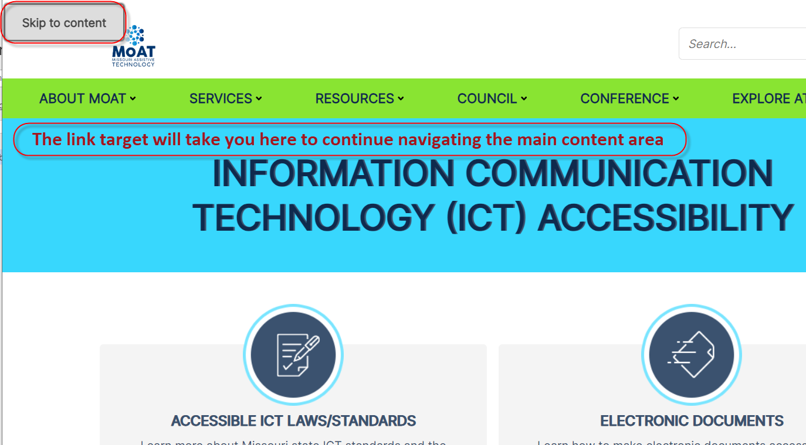

### **Content order and visual presentation**

* Use semantic html, this will give you a logical top to bottom, left to right order.
* When using the tabindex property for controlling content order, zero and negative numbers can be useful and accessible. Using a tabindex greater than zero can be problematic and you may need to rethink your content order strategy.