**HeadMouse Nano and Jelly Bean Switch**

## Orientation

The HeadMouse Nano is an external IR Sensor device that sits on the top of the laptop monitor. Place the HeadMouse in the bracket. The industrial Velcro will hold the HeadMouse in the mount. Ensure the mount grips have a width deep enough for the laptop monitor thickness. The USB Micro B port should be facing up.

Plug in the USB plug. One end in an available USB port on the laptop, and the other end to the HeadMouse. The laptop comes to the user with the HeadMouse driver pre-installed. The short cord should reach the USB port on both the laptop and the HeadMouse. If you see a red light, it is plugged in correctly. There are two light indicators on the right and left side of the device. One has a red and green status light and the other has an infrared receiver and a yellow status light.

* The red light means HeadMouse is running and looking for a target to track.
* The green light means HeadMouse has found and is tracking a target. You are connected.
* The yellow light comes on when power is applied to HeadMouse and it is being configured by your host device, or when a mouse button event is received by the infrared receiver.
  + Once HeadMouse is configured the yellow light will go out.

Locate the pair of glass frames in the kit. You should find a silver dot in the center of the frame. If you find no dot on the glasses frames, you can add one from the supply in the kit. Put the glasses on and face the HeadMouse.

Plug in the Jelly Bean switch in 2.5 mm port on the HeadMouse. This is the device that selects the mouse action (e.g., left click, right click, double click, etc.).

The movement from your head now controls the mouse movement as the HeadMouse follows the target dot. It uses IR (infrared) tracking to detect the movement of the silver dot on the glasses. Occasionally you may need to recalibrate. To do this, focus on one point in the middle of the page until the mouse finds your focus point. If this is not working turn your head away from the HeadMouse for a few seconds and turn back facing the HeadMouse again.

For typing HeadMouse uses an onscreen keyboard called [SofType](https://www.orin.com/access/softype/). You can find the desktop short cut with the same name. Or use the built-in Microsoft Onscreen keyboard.

* Focus on the desktop shortcut for SofType. Click the Jelly Bean switch twice. This should select and open the onscreen keyboard.
* The keyboard is visible along with the Dragger toolbar at the top.
* Before you begin, open a source to type in such as a Word document. Practice using the keyboard by focusing on one letter at a time, and choosing the letter by clicking with the Jelly Bean switch. Focus on typing out each letter of the word. To the left you will see a word prediction menu. If your word appears before you spell it out, select it with the HeadMouse and the Jelly Bean Switch. You should see the complete word appear in the document.
* When using a web browser, use the Tab key to navigate through the site elements.
* In addition to switch clicking once or twice, you can also access SofType Dragger toolbar. Dragger is found on the SofType keyboard. Focus on the Dragger icon you want to use. Left Drag or Right Drag (Red buttons), or Double click (yellow buttons in a bigger mouse, or Right click (Yellow button).

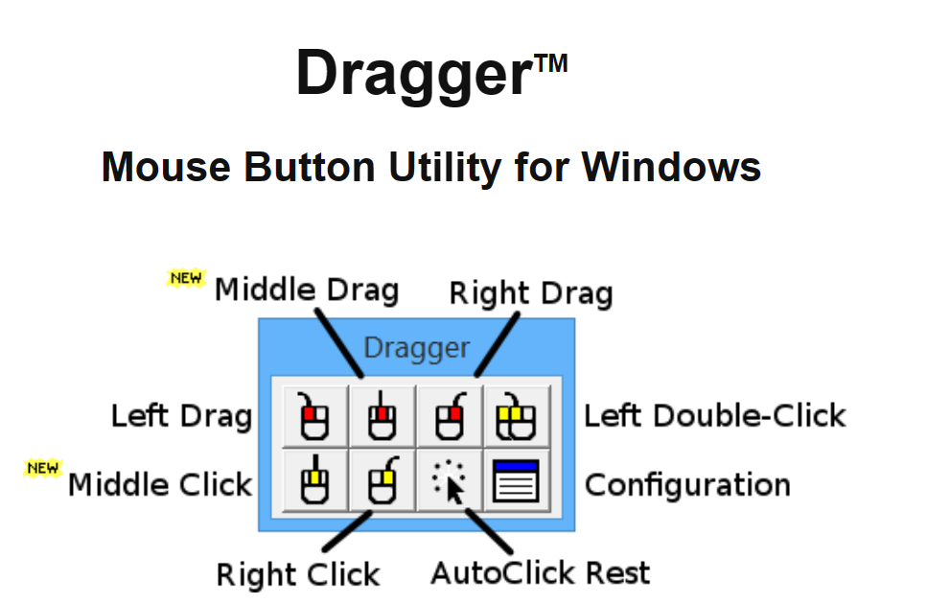

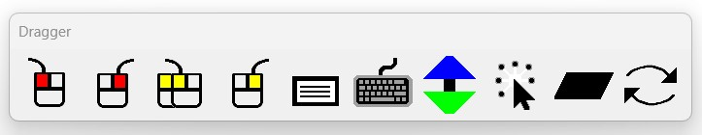

## Key Features to Know:

The HeadMouse is a hands-free mouse alternative. The HeadMouse tracks a small reflective dot that you place on part of your body, such as your forehead or a pair of glasses or hat. In this kit, it is paired with a Jelly Bean Switch for making selections.

The HeadMouse interacts with an onscreen keyboard and Dragger. The Dragger tool bar allows you additional options to select the type of mouse interaction such as right or left click or a double click action. The Dragger toolbar has icons for each mouse function such as drag, click and more.

## WCAG Applicable Guidance Related to this Device

| **Guidance** | **Criterion** |
| --- | --- |
| [WCAG 2.1 SC 2.5.1](https://www.w3.org/WAI/WCAG21/Understanding/pointer-gestures.html) | Pointer Gestures- All functionality that uses multipoint or path-based gestures for operation can be operated with a single pointer without a path-based gesture, unless a multipoint or path-based gesture is essential. |
| [WCAG 2.1 SC 2.5.2](https://www.w3.org/WAI/WCAG21/Understanding/pointer-cancellation) (Level A) | Pointer Cancellation- Single pointer functionality can be undone. Reduce accidental activation of controls by mouse or touch.  What to do: Make pointer cancellation predictable and consistent. |
| [WCAG 2.1 SC 2.1.1](https://www.w3.org/WAI/WCAG21/Understanding/keyboard.html) | Keyboard- The content is fully functional with a keyboard alone. |
| [WCAG 2.1 SC 1.3.5](https://www.w3.org/WAI/WCAG21/Understanding/identify-input-purpose) | Identify input purpose |

## Disabilities Impacted

* Limited upper body mobility to operate a traditional mouse.
* Cerebral palsy.
* Muscular dystrophy.
* Multiple sclerosis.
* Stroke.
* Spinal cord injuries.

## AT Testing Instructions

| **Website Elements to Test** | **Device Instructions** |
| --- | --- |
| Navigate to interactive elements | Focus HeadMouse on the tab button in the SofType keyboard. On a chosen interactive element, select with the Jelly Bean Switch. Target size should be minimum 44 x 44. |
| Link | Locate the link with the HeadMouse. Once the focus is on the URL link, it should view as active. Click on Jelly Bean Switch to test if the link goes to the correct URL address. |
| Button, Check Box, Radio Button | Locate the Button with the HeadMouse. Once the focus is on the URL link, it should view as active. Click on Jelly Bean Switch to test if the link go to the correct URL address. |
| Select drop down menu or Menu Bar | Dwell on the menu with the HeadMouse. Click the Jelly Bean Switch once. This should open the drop down menu, and repeat the process of dwelling on the area to target, or select the down arrow, and then click the switch to select. |
| Slider | Focus the HeadMouse on the Slider activation button. Use the Jelly Bean Switch to select. |
| Dragging | Use the Dragger toolbar left drag icon (icon with left click highlighted and a left-curved line coming out the top), to select a section of text. |
| Scroll Function Up and down, Right to Left | Use the HeadMouse to focus on the scroll bar. Short clicks on the Jelly Bean Switch while using the HeadMouse to focus moves the scroll bar down in sections. Once the cursor is focused, click the switch and hold. This activates or selects the scrolling feature. Press and hold the switch on the bar as the head mouse connects with your scrolling movement. The head movement and switch focus must match or the scrolling will stop. In other words, keep your eye on the scroll bar. |

## Resource Video

[HeadMouse](https://youtu.be/CKSXEAhrpXw) User

[Bureau of Internet Accessibility](https://www.boia.org/blog/understanding-assistive-technologies-what-is-a-head-mouse-system)

[Using a computer with a HeadMouse](https://youtu.be/T3-3C5skFmA)

[4:30 minutes in is settings for HeadMouse](https://youtu.be/kTQMC-02ALw?si=SWjWaHS9GXUWpHKg)