**ZoomText**

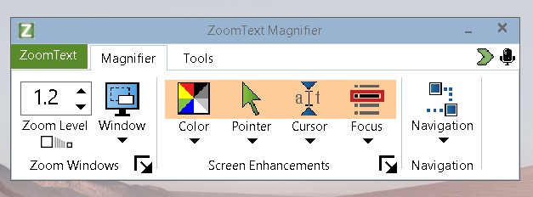

To set up the Zoom text magnification and split screen:

* Access the Magnifier tab> Windows> settings>window type> Docked Top.
* Next access Magnifier tab> Zoom Level spin box> increase magnification number. Try 3.
  + Caps locks + down reduces magnification.

## What web browsers does ZoomText work with?

* ZoomText visually tracks as you navigate websites in Google Chrome, Mozilla Firefox, and Internet Explorer. Support for Microsoft Edge is continuing to improve as well.

## Key Features to Know:

Zoom text software offers control over the following magnification and focus:

* Magnification up to 60 times.
* Dock the magnification portion of the screen at the top or bottom of the screen for testing.
* Multiple options for color contrast.
* Multiple options for cursor size and appearance.
* Multiple options for focus highlighter.
* To escape out of magnification, CAPS lock + Enter returns to normal. IT can also toggle back to magnification selected.

## WCAG Applicable Guidance Related to this Device

| **Guidance** | **Criterion** |
| --- | --- |
| [WCAG 2.1 SC 1.4.4](https://www.w3.org/WAI/WCAG21/Understanding/resize-text.html) | Create Web content that does not prevent the user from scaling the content effectively to a scale they can read. |
| [WCAG 2.1 SC 1.4.13](https://www.w3.org/WAI/WCAG21/Understanding/content-on-hover-or-focus) | Content on hover or focus. |
| [WCAG 2.1 SC 1.4.3](https://www.w3.org/WAI/WCAG21/Understanding/contrast-minimum) | Sufficient color contrast. Color involved in an action should be easily seen. |

## Disabilities Impacted

* Low Vision

## AT Testing Instructions

| **Website Elements to Test** | **Device Instructions** |
| --- | --- |
| Navigate to interactive elements | You can use keyboard or mouse navigation to move across elements. Check the quality of magnification as you move across the page.   * Check resized text, font quality and so forth. |
| Link, Button, Check boxes and Radio buttons (Hover test) | 1. Change the pointer to view the elements.    1. Pointer- Magnifier tab > drop down> Select a Scheme (Giant green pointer)       1. Does the tool tip display behind or next to the enlarged pointer? 2. Change the Cursor to view the elements.    1. Cursor – Magnifier tab> drop down>Select a scheme>(Blue wedge)       1. Does the cursor focus remain with the 3. Change the focus tool to view the elements.    1. Focus> Magnifier tab> drop down>Select a scheme> (Red Rectangle) 4. Change the color contrast to view the elements.    1. Color> Magnifier tab> drop down>Select a scheme> (White on black) and (Yellow blue test) |

## Resource Video

[getting started](https://doccenter.freedomscientific.com/doccenter/archives/2019_03_07_Getting_To_Know_ZoomText/Getting_to_Know_ZoomText_Webinar.mp4)

[Learn more about Color Enhancing Settings](https://youtu.be/m7ukz3ue0Ik?si=9OTLZZxkgOo4brTc)

[Learn more about the Focus Enhancing settings](https://youtu.be/DJUpCan0moM?si=_NqUn-id59pmKa4r)

[Keyboard commands](https://www.freedomscientific.com/training/zoomtext/zoomtext-hotkeys/)