Tips for Making Online Classroom Documents Accessible

Google Docs

Font Size and Alignment
To make your document easy to read for low vision, use large font (size 18 – 24) and select left-aligned text when possible. Justified text is more difficult to read because of extra space between the words. If font size 28 is needed, considerations for education on Braille technology might be beneficial. APH is a great reference for more information.

Use of Color
Use high color contrast to make text and images easier to read and comprehend. Web Content Accessibility Guidelines (WCAG) 2.0 recommend a minimum ratio of 4.5:1 for large text and 7:1 for other text and images. For example, avoid light gray text on a white background.
Here is a visual reference for Good and Poor contrast choices:
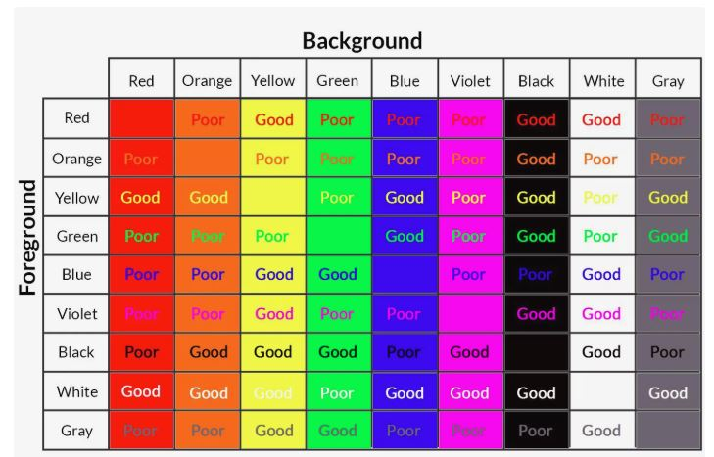
To use an online color contrast checker, use the WebAIM contrast checker. A tool such as Color Cop can help grab the Color codes to use on the WebAIM contrast checker.

Headings and Structure

Headers add structure to your Google Doc when you nest Headings. Headings divide your document into sections, making it easier for people using keyboard shortcuts to jump to a section. Use the heading styles.

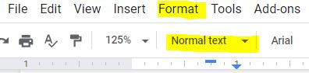

Landmarks like headers, footers, page numbers, and page counts help your readers find where they are in your document. To maximize accessibility, especially in long documents, include one or more of these landmarks found in the Insert menu.

Use numbered and bulleted lists
Google Docs can automatically detects and formats some lists for accessibility. For example, if you start a new line in your document by typing the number 1 followed by a period, the new line automatically becomes the first item in a numbered list. To confirm if your content is automatically identified as a numbered or bulleted list, look at the tool bar while on your list and confirm that the numbered list or bullets tool is highlighted.
It is best to not depend on an automatic format and select the numbered or bulleted list on your first item by accessing the tool bar. 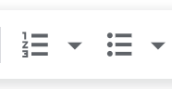

Images
When you Inset an image, you must add Alt Text. If you do this after inserting the photo, right click once on the photo for menu options. Select Alt Text. Add a meaningful description that connects the image to the reason it was included in the document. 2 to 3 sentences is adequate to describe the image.
When you consider placement of the image with the content, keep it simple and select in-line with text.

Tables
Tables cannot truly be made accessible within Google Docs. We suggest using another format such as Microsoft Excel or Microsoft Word to share table. Follow Microsoft guidelines for creating accessible tables.
Microsoft Word – Creating Accessible Tables
Microsoft Excel- Creating Accessible Tables

Tables can have some adjustments made to become accessible with Grackle Docs. Here is a link for making tables accessible in Google Docs using the for purchase add on, Grackle Docs.

Hyperlinks
When inserting a web link, use the tool option Insert, and select Hyperlink. You will see a box with 2 form fields. One for descriptive hyperlink text and the next for the website link. Use the text box to adequately describe what the reader will be directed to, when clicking on the link.
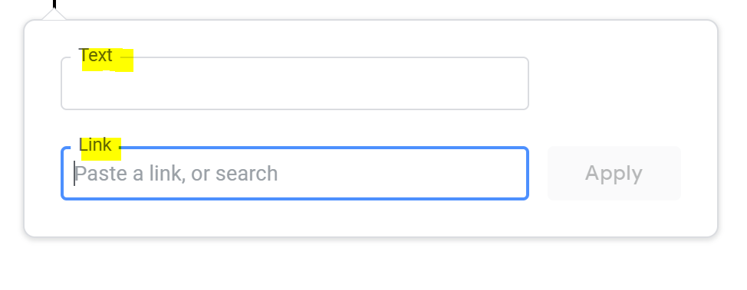

Accessibility Checker for Google Docs
Use a for purchase Add-on tool for checking Google Docs accessibility! Grackle Docs offers a free trial. Once your Google Document is accessible, Grackle Docs helps you convert this into a PDF maintaining the accessibility you just built into the document.

Resources for AT Users Accessing Google Docs
Google Support offers instructions for Screen reader users on how to set up accessibility in Google Docs for the AT User.
Google Support offers instructions for Braille device users on how to set up accessibility for their device in Google Dos, in several platforms.
Freedom Scientific instructions on using Google Docs with a screen reader or Braille device.

Microsoft Word Documents

Use built in styles to create Headings
Use the build in styles from the ribbon. Your main title should be heading 1. The documents main section headings are heading 2. Subsections are heading 3 and regular paragraph text is normal. You can alter the visual appearance of the style but right clicking on the style and clicking "modify." You can make this visual appearance (font, size) the default in all documents by clicking "new documents based on this template"

Lists
Use Word's preformatted bullets and lists. This may auto format when you create a list or you can make sure it is used by selecting it from the paragraph portion of the ribbon.
- apple
- orange
- banana

Images
- Right-click on the image;
- Select Edit alt text
- In the Alternative text box, type in the description of the image.
Note 1: Decorative images without meaningful content should not have any alternative text.
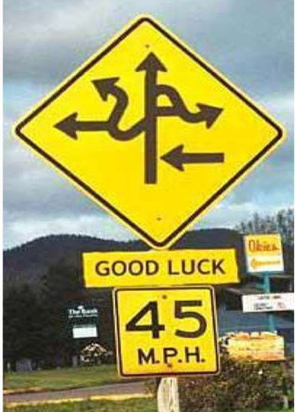 Note 2: Background images or watermarks do not have to be tagged. When the document is converted to PDF these images will not be detected and will not have to be tagged

Tables
Use the preformatted insert table feature in Word when including tables. Tables with column headings in the top row must have the top row formatted as a header row.
- To set a table header row:
- Highlight the top row of the table
- Right click to display editing options
- Select “Table Properties” from the list.
- The Table Properties window will be displayed; click on the “Row” tab
- Check the option “Repeat as header at the top of each page”
- Click on OK
Fruit | Cost
Apple | 1.34
Banana | .69
Grapes | 3.99

Hyperlinks
Hyperlinks should be active (they turn blue) when they are copied into the document. If the links are not active they may be made active by using the “Insert Hyperlink” command.
- First highlight the text that needs to be made active;
- Then click on Insert;
- Then Hyperlink (Ctrl + K) - or click on the icon that that has a chain overlapping the bottom of a ball.
You can also right click on your mouse at the point where you wish to insert a hyperlink, and select “Hyperlink” from the dropdown menu. It is strongly suggested that you copy and paste the hyperlink directly from the Internet page to avoid making mistakes when typing the URL manually. Do not insert "click here" as the name of the link. Use a description!
Google

Extra information
Do not use tab or space to arrange columns, words, or text. This causes the screen reader to read all the empty lines and spaces. Best practice is to use the preformatted styles and templates already available in Word. Use "insert page break" to start a new page instead of hitting enter until you are at the top of a new page.

Swift Add On Tool for Word
Swift is a free download that allows you to format your Word document for easy transcription to Braille. It can be found here download Swift. It is used in conjunction with Duxbury software.

MathType
Mathtype is a purchased download that allows you to enter a variety of math text (in mathxl format) into a word document. This can then be correctly transcribed by Duxbury into Braille. You can download a free trial here download MathType.

Accessible Classroom Resources
- Download google file stream Detailed instructions are below.
- Accessible word document video
- Accessible Power Point video
- Video on using google file stream

Download Google File Stream

- Go to the website
- Click on "Download & install File Stream"
- Choose Download for Windows, and it will automatically download to your computer.
- Navigate to downloads (either in notifications or through file explorer) and click on the download to open.
- A notification will probably ask you if you want to make changes to your computer. Choose "yes".
- Google File Stream will download. You may get a notification to log into your google account. Use your school email and password.
- You may need to restart the computer for it to display.
- Google File Stream is now a file choice in File explorer. You can open documents directly from this file and save documents to it. This allows you to create a document in Word (which is more accessible) and then save directly to your shared drives for your teachers.
- You also can open documents your teachers have put in google on your computer, edit them in Word, and then save so they can look at your work.

The Department of Elementary and Secondary Education does not discriminate on the basis of race, color, religion, gender, gender identity, sexual orientation, national origin, age, veteran status, mental or physical disability, or any other basis prohibited by statute in its programs and activities. Inquiries related to department programs and to the location of services, activities, and facilities that are accessible by persons with disabilities may be directed to the Jefferson State Office Building, Director of Civil Rights Compliance and MOA Coordinator (Title VI/Title VII/Title IX/504/ADA/ADAAA/Age Act/GINA/USDA Title VI), 5th Floor, 205 Jefferson Street, P.O. Box 480, Jefferson City, MO 65102-0480; telephone number 573-526-4757 or TTY 800-735-2966; email civilrights@dese.mo.gov.

