Portable Ramps
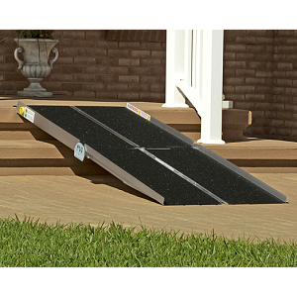 | Prairie View Industries Multifold Ramp  Portable ramps come in several types and are used in several ways. Ramps that fold can come in double, triple or single fold options. The multifold separates into two pieces for easy carrying. Some fold like a suitcase. Others are solid pieces that will need space for storage and portability. | Manufacturer:  Prairie View Industries  http://www.pviramps.com  Use: Building or vehicle  Approximate Cost:$105 to $325
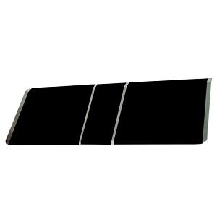 | Prairie View Industries-Bariatric Threshold Ramps  Designed for doorways, holes punched in top corners for easy installation  - Lightweight, Durable Aluminum  - Anti-Slip, High Traction Surface  - Hardware Provided to Secure Ramp to Surface | Manufacturer:  Prairie View Industries  http://www.pviramps.com  Use: Building threshold  Approximate Cost: $450 to $685
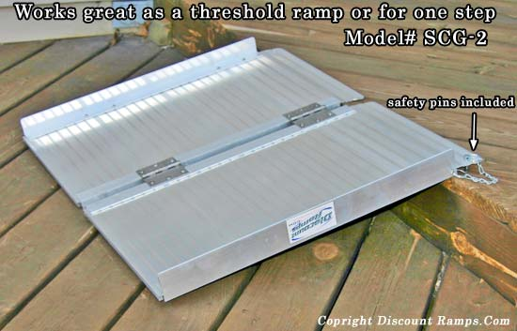 | PORTA-RAMP  These ramps fold to half their width but stay their full length so they can be deployed in seconds. They have a built in traction surface that does not wear off and they include a carrying handle so they can be carried like a suitcase (SCG-2 ramp does not include a suitcase handle because it would hit the ground on a 4" rise). Their all aluminum construction allows them to be lightweight for their size. They are heavy duty and have a 600 lb weight capacity. These ramps conveniently load manual or power wheelchairs, scooters, or just about anything with wheels onto porches, curbs, and landings, and the 6 foot model will even load into some minivans. Five lengths are available to fit many loading requirements and heights. | Manufacturer:  Rage Powersport Products  http://www.discountramps.com/handicap_ramp.htm  Use: Building or vehicle  Approximate Cost: $70 to $190
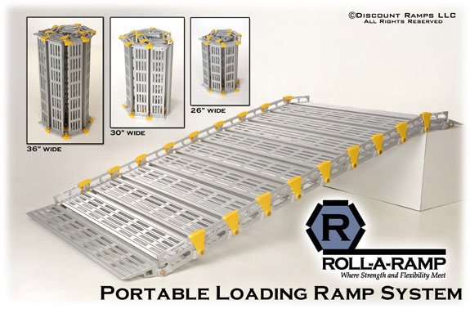 | Roll-a-Ramp  The design allows them to be rolled up or folded for storage / transport. All the Roll-A-Ramps are fabricated of aerospace aluminum making them lightweight, rust proof, strong, and easy to set up! The portable ramps are available in 26", 30", and 36" widths and can be customized to any length! Optional accessories are available for enhancing the Roll-A-Ramp system which include 1 foot extension links, support stands, and tailgate brackets for extra hold to keep the ramp from kicking out. | Manufacturer:  Rollaramp  http://www.discountramps.com/roll-a-ramp.htm  Use: Building or vehicle  Approximate Cost: $300 to $1,260
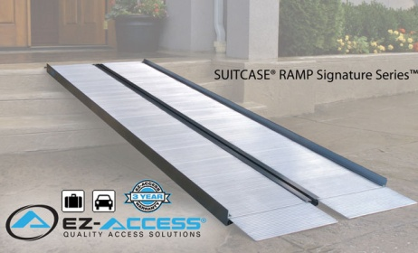 | Suitcase Ramp  The SUITCASE® RAMP Signature Series™ features heavy-duty, light weight air-craft grade aluminum suitcase-style wheelchair ramps designed specifically for ease of use and the convenience of portability. Offers flexible, non-breakable handles with a comfortable grip, bottom transition plates help adjust to accommodate uneven terrains, and a non-skid surface. Each ramp is recommended for use with wheelchairs & scooters, holding up to 800lbs and features a 3 Year manufacturer warranty from EZ-Access.  EZ-Access also has optional accessories to help make their ramps even more convenient. The Top Lip Extension, or TLE, increases the reach by extending the standard ramp lip from 3" to 9" in length. Uniquely, the TLE can be added or removed as needed and is primarily intended for unoccupied use only, up to 500 lbs Another optional accessory is the Rubber Threshold/Cargo Wedge Ramp™ which can be shaped to fit inside a vehicle to smooth transitions to and from the ramp. | Manufacturer:  EZ Access  http://www.discountramps.com/signature-suitcase-wheelchair-ramp.htm  Use: Building or vehicle  Approximate Cost: $110 to $390
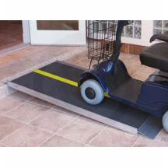 | PATHWAY LITE  The PATHWAY® LITE is a solution for temporary or semi-permanent home access. Ramp features a solid, seamless design, making it ideal for use with scooters, wheelchairs, and walkers. This ultra-strong ramp provides the safety and strength required while remaining lightweight and portable. No assembly or folding required – simply position the ramp and it's ready to use. Features an applied skid-resistant surface and a selfadjusting bottom transition plate for easy conversion from ramp to ground. Manufactured of welded aircraft-grade aluminum. | Manufacturer:  EZ Access  http://www.healthcarerxequip.com/  Use: Building threshold  Approximate Cost: $170 to $500

Modular Ramps
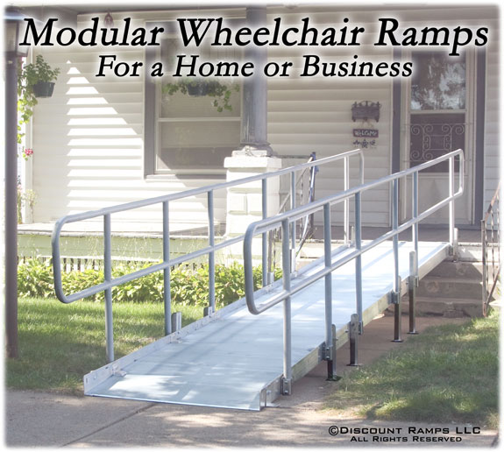  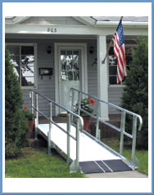  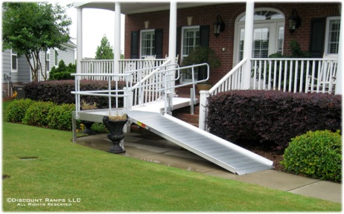 | Modular Ramps  These all aluminum modular wheelchair ramp systems are the perfect solution for both home access and commercial use and can bring your business into ADA compliance. Do not risk a lawsuit by not being up to federal ADA standards. This 36 inch wide modular ramp system has a load carrying capacity of 100 pounds per square foot. These modular ramps consist of standard components that can be assembled quickly and easily with common hand tools. The modular wheelchair ramp components make it easy to move the ramp to a new location or change the configuration. Straight ramps, 90 degree turns, 45 degree turns, and 180 degree switchbacks are designed to meet ADA recommendations. Standard handrails consist of two 1½ inch diameter horizontal rails. (Optional ADA extensions and guard rails with vertical slats are available on request.) This system is able to accommodate architectural inserts to complement the surroundings. These modular wheelchair ramp systems are strong, durable, portable, and flexible, yet are affordable enough to make it the best alternative to provide quality functional access to many areas. These are great wheelchair ramps for the home or for a business to bring you up to ADA requirements. | Manufacturer:  Modular Ramps  http://www.discountramps.com/modular_ramps.htm  Use:  Approximate Cost:$363 and up depending on length and quantity

Lifts and Elevators
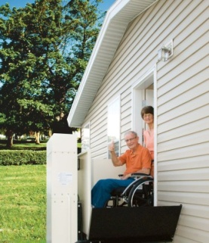  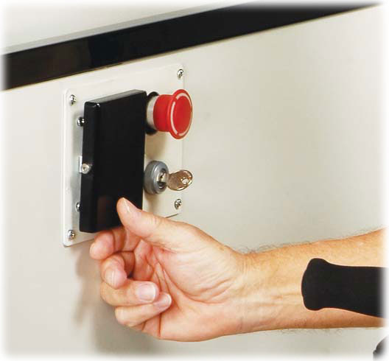 | Vertical Platform Lift  This type of device offers an option for access to an outside entrance or garage door entrance to the home. A push button activates the lift at the top and the bottom. Options to consider include back up batteries and gates to enclose individual on the lift while in operation. | Manufacturer:  Amramp  http://www.amramp.com  Use: Buildings  Approximate Cost: $3,695 to $20,000
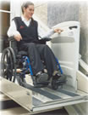 | Incline Lift  This stair lift holds a chair user in the device and travels up the incline. It offers access to multi-floor homes and properties and can be used indoor and outdoor. Has an onboard and remote controls allow independent use | Manufacturer:  Varies (Harmar or Butler)  http://www.amramp.com/stair-lifts  Use: Buildings  Approximate Cost: $3,695 and up
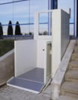 | Elevator  This type of home elevator is like a porch lift that is enclosed in shaft. The shaft can be dry wall with doors, plexiglass or metal enclosure. A pit required or permanent ramp for access to lift at bottom. | Manufacturer:  Varies  http://www.silvercross.com/homeelevators.html  Use:  Approximate Cost:$1,000 to $20,000
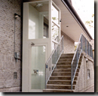 | Elevator  Elevators can be as lavish or modest. | Manufacturer:  Varies  http://absoluteaccesskc-px.rtrk.com/  Use:  Approximate Cost:$1,000 to $20,000

Ramp Resources

Home building companies such as Lowe’s offers a guide and materials to build a permanent ramp: http://www.lowes.com/Building-Supplies/Wheelchair-Ramps-Components/_/N-1z0yk1t/pl

Ramp Safety:

Ramp Length Calculator: http://www.pviramps.com/products/ramp-length-calculator.php
Modular Ramp Specification: http://www.modular-wheelchair-ramps.com/Modular_Ramps/ADA_Modular_Ramp_Specs.aspx

Find a ramp dealer:
Prairie View Industries: http://www.pviramps.com/find-dealer/
Rage Powersports: http://www.ragepowersports.com/where-to-buy/
Rollaramp: http://www.rollaramp.com/store.asp?pid=30197&catid=19991
EZ Access: http://www.ezaccess.com/support/find-a-dealer.asp

NOTE: The portable ramps and lifts products and noted resources, are shown only to give a few examples of available options, rather than any kind of endorsement of products.

