# **STATE OF MISSOURI DIGITAL ACCESSIBILITY ROADMAP MoAT, Missouri Assistive Technology LogoState of Missouri, OA-ITSD Logo**

Introduction 3

For technical support regarding WCAG: 3

For administrative support regarding this roadmap: 3

DEADLINE: By June 30, 2025 4

Step 1: Learn about the current and new requirements for web accessibility 4

Step 2: Assign a designated Agency Digital Accessibility Coordinator 4

DEADLINE: By September 30, 2025 5

Step 3: Ensure training completion by Digital Accessibility Coordinator through the State’s Learning Platform, MOVERS Learn 5

Step 4: Conduct an audit of major web properties, including prioritizing the content 5

Step 5: Familiarize yourself with the exceptions 7

DEADLINE: By November 30, 2025 7

Step 6: Test your current content for accessibility 7

Step 7: Develop an action plan summary for each Website/Web Application 10

DEADLINE: April 24, 2026 11

Step 8: Work through your action plan 11

Step 9: Develop a status report 12

Step 10: Submit your agency’s Digital Accessibility Plan 13

DEADLINE: On/After April 24, 2026 14

Step 11: Maintain the accessibility of your content 14

**Instructions:**

This is an example roadmap that local government, education institutions, etc. can use as a boiler plate to create their own organization roadmap. Non state government organizations can remove the state accessibility law and other state references.

## Introduction

The following roadmap[1] (developed by MO Assistive Technology and Office of Administration-ITSD) outlines step-by-step directions for how to get your agency compliant with the state’s Web Accessibility law and standard as well as the Federal 2024 Department of Justice (DOJ) Title II Update. There will also be a separate companion Digital Accessibility Plan document to fill out specifically for your agency.

### For technical support regarding WCAG:

* Lainie Strange - [lainie.strange@oa.mo.gov](mailto:lainie.strange@oa.mo.gov)

### **For administrative support regarding this roadmap:**

* Missouri Assistive Technology - [info@mo-at.org](mailto:info@mo-at.org)

We know that accessibility can seem daunting at first. But with the right plan, the right people, and some hard work, we can ensure people with disabilities are able to access our government services without unnecessary obstacles.

## DEADLINE: By June 30, 2025

### Step 1: Learn about the current and new requirements for web accessibility

Your first step should be to **become familiar with the Web Content Accessibility Guidelines (WCAG) 2.1, the state web accessibility standard and the DOJ Title II final rule**, in order to understand what is involved. Here are some helpful resources in order to expand your knowledge:

* [Missouri State Accessibility Law and Standard](https://at.mo.gov/ict-laws-standards/)
  1. Effective in 1999, [**Section 161.935, RSMo**](http://revisor.mo.gov/main/OneSection.aspx?section=161.935&bid=7938&hl=), requires accessibility in the development, procurement, maintenance or use of Information and Communication Technology (ICT), or when administering contracts or grants that include the procurement, development, or upgrading of ICT.
  2. The [**State Accessibility Standard document**](https://at.mo.gov/ict-laws-standards/) (created in 2003 and most recently updated in 2024) outlines what specific standards to follow, what content types are included and what are exemptions.
  3. Our standard document references the **Web Content Accessibility Guidelines (WCAG)**:
     1. Effective 3/13/25 - [WCAG 2.1 A/AA](https://www.w3.org/WAI/WCAG22/quickref/?currentsidebar=%23col_customize&versions=2.1&levels=aaa) (W3C), [WCAG 2.1 guide including plain language descriptions](https://accessible.org/Kris-Rivenburgh_WCAG-2.1-AA-Guide.pdf) and
     2. Effective 4/6/26 - [WCAG 2.2 A/AA](https://www.w3.org/WAI/WCAG22/quickref/?currentsidebar=%23col_customize&versions=2.1&levels=aaa) (W3C), [WCAG 2.2 guide including plain language descriptions](https://accessible.org/Kris-Rivenburgh_WCAG-2.2-AA-Guide.pdf)
* [Department of Justice (DOJ) Title II Final Rule on the Accessibility of Web Content and Mobile Apps Provided by State and Local Governments (April 2024)](https://www.ada.gov/resources/2024-03-08-web-rule/) Plain Language Fact Sheet

Before moving onto other steps of the roadmap, make sure that your agency’s leadership and legal teams are aware of the MO State Accessibility Law/Standard and the DOJ final rule. They need to be involved in this process from the very beginning.

Other than reviewing the above resources, do not worry too much about specifics yet. Accessibility is a process, not a destination. Learning the basics will be enough to move on to the next steps of the roadmap, and your knowledge will continue to grow.

### Step 2: Assign a designated Agency Digital Accessibility Coordinator

Now that you know general information about what is expected from each agency, it is time to figure out who is going to have a role in making sure your agency complies with the MO State Accessibility Law/Standard. Here are some things to consider:

* Think broadly about who should be involved: While web developers or information technology (ITSD) staff play an important role, they are not the only ones who should be thinking about accessibility. For example, procurement staff play a key role in ensuring your agency buys or licenses accessible technology. Communications staff serve as a last line of defense to protect against inaccessible content/documents on agency websites and social media platforms. It is important to clearly identify who is responsible for what, so that there is no confusion.
* **Designate a digital accessibility coordinator:** Of those involved in your agency’s accessibility efforts, which person:
  + Has the expertise in web accessibility (or ability to gain such expertise) to serve as your agency’s digital accessibility coordinator.
  + Is a full-time employee of your agency.
  + Can exercise appropriate control to enforce accessibility requirements. This does not necessarily mean the individual must be the Executive Director (or other high-level administrator) of the agency, but the individual must be authorized to direct other agency personnel in what must be done before web content is approved to be posted.

**ACTION ITEM: Notify Missouri Assistive Technology,** [**info@mo-at.org**](mailto:info@mo-at.org) **of your agency’s designated Digital Accessibility Coordinator by June 30, 2025.**

* As part of this process, you will create an [Agency Digital Accessibility Plan](https://at.mo.gov/wp-content/uploads/web-accessibility-plan-template-1.docx).The template includes a definition of the Digital Accessibility Coordinate role and other accessibility roles within your agency.

## DEADLINE: By September 30, 2025

### Step 3: Ensure training completion by Digital Accessibility Coordinator through the State’s Learning Platform, MOVERS Learn

**ACTION ITEM: Digital accessibility coordinators must complete web accessibility training within 90 days of hire or designation to the role**. The training materials may be determined by the agency head. Some options include:

* The Digital accessibility coordinators training recommendation is outlined in your agency’s Digital Accessibility Plan Document under the Training section.
* Missouri Assistive Technology/ITSD is currently developing an “all-staff” Digital Accessibility Awareness/Document Accessibility course that will be published through the MOVERS Learn platform and will be available by June 30, 2025.
* Other role-based training is outlined in the training recommendation section of the Agency Digital Accessibility Plan.

### Step 4: Conduct an audit of major web properties, including prioritizing the content

The next step is **to start doing an audit of your agency’s web content from a 30,000-foot level**. Depending on the size and nature of your agency, the amount of web properties can vary.

Example web properties include:

* Public website content and digital documents
* Secure login web applications
* Social media pages
* Intranet Website Content and Digital Documents (State Government only)
* 3rd party contracted or licensed website content, web applications and Digital Documents
* Mobile Applications

#### Audit Spreadsheet

Here is an [audit spreadsheet template](https://at.mo.gov/wp-content/uploads/state-accessibility-plan-website-document-audit-template.xlsx) (includes example entries)

The audit spreadsheet will record things like:

* Website or Application Name
* Business Owner
* Technical Owner
* Priority Score
* # of pages/documents
* # of unique visitors
* Accessibility testing status

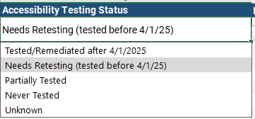

Figure 1 Screenshot of accessibility testing status dropdown in the audit spreadsheet

**NOTE: Remediation Action Plan Column and Status April 2026 Column**There are two columns called “remediation action plan” and “Status April 2026”. These two columns will be filled in at Steps 7 and 9. They are not required at Step 4

**ACTION ITEM: Create and submit your agency’s web properties audit to Missouri Assistive Technology -** [**info@mo-at.org**](mailto:info@mo-at.org) **by 9/30/25.**

#### Prioritizing Web Properties in the Audit Sheet

As part of each web property record, there is a priority level assigned.

This will be influenced by:

* + **How critical a website is to your organization’s daily operations.** (Like applying for jobs, processing a grant application or filing your taxes)
  + **The amount of users to each website or web application** over a year’s time, if records permit. For websites, you could look at unique users in analytics data or for secure web applications, the user count from the user database. See the below information about prioritization based on number of external users.

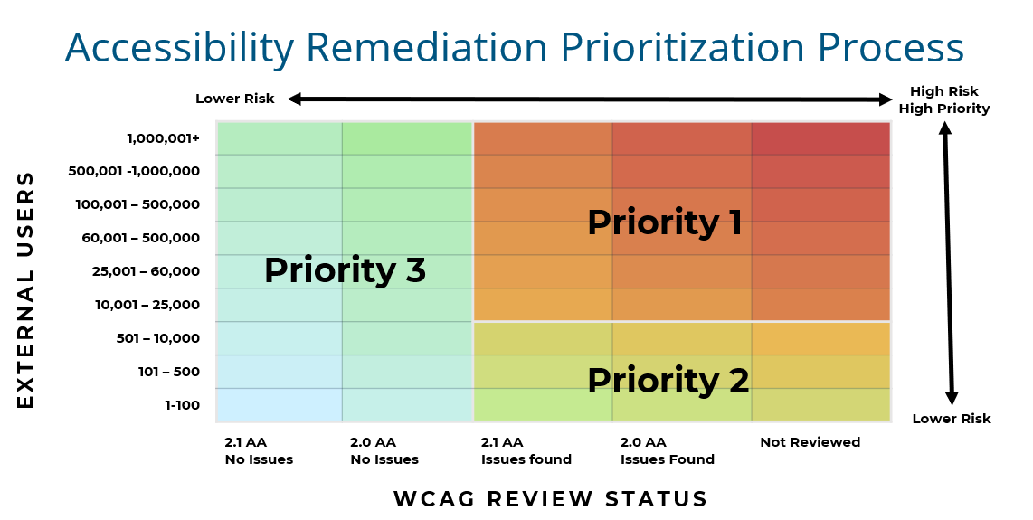

Figure 2 Suggested accessibility remediation prioritization process chart, identifying priorities 1, 2, 3

**Priority 1:** External User Count of 10,001 or more yearly users, with either known WCAG 2.0, WCAG 2.1 issues or the site has never been tested.

**Priority 2:** External User count of 1-10,000 yearly users, with either known WCAG 2.0, WCAG 2.1 issues or the site has never been tested.

**Priority 3:** Any user count, no WCAG 2.0 or WCAG 2.1 issues during last test.

### Step 5: Familiarize yourself with the exceptions

Now that you have a handle on all of your agency’s major web properties, you are ready for the next step: **Familiarize yourself with the exceptions referenced in the** [**Missouri State ICT Standard document**](https://at.mo.gov/ict-laws-standards/)(page 5, Exceptions Related to Section 508 and Title II). Here is an [additional resource on the DOJ Title II exceptions, with examples](https://www.ada.gov/resources/2024-03-08-web-rule/#summary-of-the-exceptions).

The overall purpose of the exceptions is for your agency to focus remediation efforts on the content that matters most instead of focusing time, effort and money fixing things that people are likely not regularly accessing.

Please include your Legal Team in the review of the DOJ Final Rule before moving forward with this step in the roadmap.

## DEADLINE: By November 30, 2025

### Step 6: Test your current content for accessibility

Having reviewed the Exceptions, **you are ready to test the accessibility of your current content**. Good accessibility testing usually combines the use of automated evaluation tools with manual checks, such as keyboard testing and color contrast.

#### Create a Webpage/Document Inventory: Inventory Spreadsheet

We first need to inventory the content of each website and intranet site. We have available a [Digital Accessibility Inventory Spreadsheet Template](https://at.mo.gov/wp-content/uploads/state-accessibility-plan-webpage-document-inventory-template.xlsx). You may find you do not necessarily need this spreadsheet for interactive web applications.

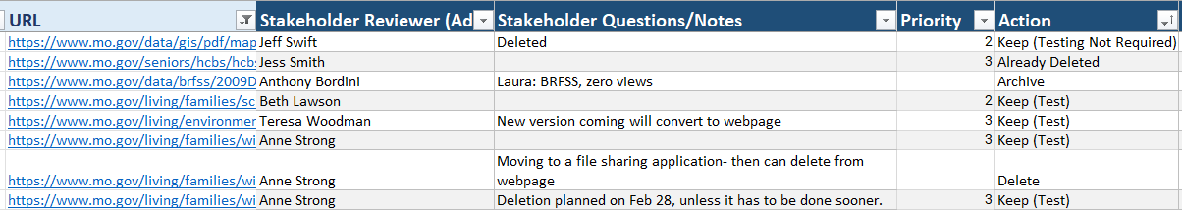

Figure 3: Screenshot of Inventory Spreadsheet

#### Testing Process

Many enterprise-level automated tools can expedite the process by checking the accessibility of many webpages or documents at once. The State of Missouri does use such a tool from [Siteimprove](https://at.mo.gov/it-access/siteimprove) for this effort. Keep in mind, no automated tool can fully judge whether a website or document is accessible on its own, and you should be cautious of any vendor that claims their product can. But these tools are still very valuable and can help speed up testing significantly.

Checklists:   
Accessibility testing has a lot of steps, which increases the chances of something being forgotten or overlooked. Given this, it is important to use some kind of checklist to make sure that everyone is checking things consistently every time.

The following are helpful checklists to create accessible content:

* [Word 365 Accessibility Checklist](https://at.mo.gov/wp-content/uploads/word-365-accessibility.pdf)
* [PowerPoint 365 Accessibility Checklist](https://at.mo.gov/wp-content/uploads/powerpoint-365-accessibility.pdf)
* [Excel 365 Accessibility Checklist](https://www.hhs.gov/sites/default/files/os-a11y-excel-reference.pdf)
* [PDF Accessibility Checklist](https://at.mo.gov/it-access/your-9-step-pdf-accessibility-checklist/)
* [Video Accessibility Checklist](https://at.mo.gov/wp-content/uploads/mo-at-multimedia-accessibility-checklists.pdf)
* [Plain Language Checklist](https://at.mo.gov/wp-content/uploads/plain-language-quick-guide.pdf)
* [State of Missouri Website and Web Application Testing site (including checklist)](https://at.mo.gov/ict-websites-webapps/)

Sort and Evaluate to Determine What Needs To Be Tested  
In-depth testing will reveal the content that is the most inaccessible. This will help you to sort and prioritize your work even more. Categorize your content into these four (4) buckets as follows:

**Bucket 1: Remove**

* Any obsolete or redundant content that you can safely remove or delete goes in this bucket. You will want to remember to take your agency’s Record Retention policies into account, but the more content you can delete now, the less content you have to fix later.

**Bucket 2: Ignore**

* Any content you need to keep that qualifies for [DOJ Title II Exceptions 2- 5](https://www.ada.gov/resources/2024-03-08-web-rule/#summary-of-the-exceptions) goes in this bucket. Since this content qualifies for an exception, you can safely ignore the requirement to make it accessible (unless requested).

**Bucket 3: Archive**

* Any content you need to keep that qualifies for [DOJ Title II Exception 1](https://www.ada.gov/resources/2024-03-08-web-rule/#summary-of-the-exceptions) goes in this bucket. All five of the exceptions eliminate the need for you to make the content accessible by 4/24/2026, but DOJ Title II Exceptions 2- 5 do not have any extra requirements for the content like Exception 1 does. That is why this content gets its own bucket.

**Bucket 4: Update**

* Any remaining content that does not belong in the other buckets will end up in this bucket. It should contain any content you need to keep but does not qualify for an Exception. The content in this bucket is what you will need to make accessible by the 4/24/2026 compliance deadline.

The inventory spreadsheet will include an Action column to designate for each page or document. You can then sort by the content that needs to be tested.

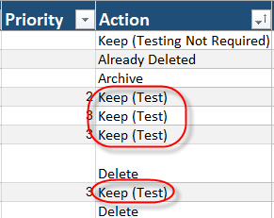

Figure 4: The inventory sheet includes an action column to determine what content needs to be remediated.

#### Digital Accessibility Evaluation Report Template

Next, you may need to record your accessibility errors, especially if someone else is making the fixes. Siteimprove does record accessibility findings for both webpages and PDF documents that you can export as a report. To record other issues not detected through automated tests, we have a [template you can use to record errors](https://at.mo.gov/wp-content/uploads/accessibility-check-template.docx). The report is especially helpful if you are passing on fixes for someone else to fix.

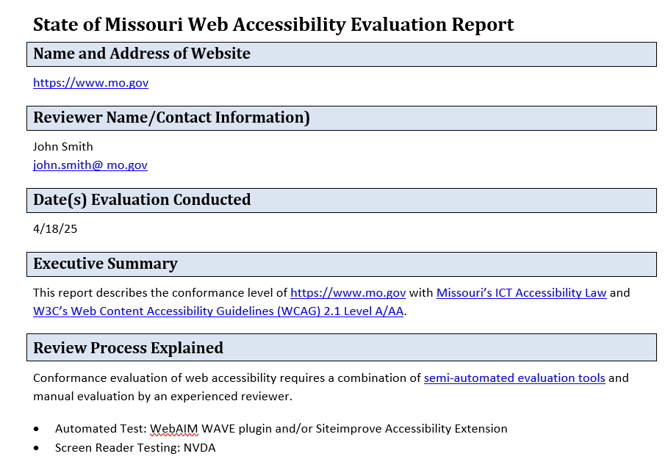

Figure 3: Screenshot of Sample Web Accessibility Evaluation Report

### Step 7: Develop an action plan summary for each Website/Web Application

Now that you performed your accessibility test, you can go back to your agency audit spreadsheet from Step 4 and record a remediation action plan summary for each web property. This action plan will be summarized under the column “Notes/Remediation Action Plan”**.**

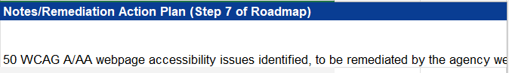

Figure 4: Sample remediation action plan summary

The summary must provide:

1. The quantity, nature and severity of accessibility issues identified for each major web property. The summary should be based on the content in **Bucket 4 from Step 6**.
2. Specific information regarding who, when and how the accessibility issues for each major web property will be brought into compliance.

#### Summary Examples

For example, Agency X manages two major web properties. Based on the results of our accessibility testing, the remediation action plan is as follows:

1. Website: <https://myui.mo.gov> 50 WCAG A/AA webpage accessibility issues identified and will be remediated by the agency web development team. 50 PDF files with accessibility issues will be remediation by Communications department. All will be completed no later than 3/31/2026.
2. Facebook: [facebook.com/department](http://www.linkedin.com/in/department). Content falls under Exception 3, all social media posts prior to 4/24/2026 are not required to be accessible, unless requested. Therefore, no corrective action needed.

If you have any questions related to the action plan, please contact the web accessibility coordinator, Lainie Strange, [lainie.strange@oa.mo.gov](mailto:lainie.strange@oa.mo.gov), 573-751-1570.

**Once developed, the action plan information must be submitted to Missouri Assistive Technology,** [**info@mo-at.org**](mailto:info@mo-at.org) **by November 30, 2025.**

## DEADLINE: April 24, 2026

### Step 8: Work through your action plan

It is finally time to do something with your web content. Of all the steps in the roadmap, this is the one that will take the most time and effort. It is also the step that is most critical to get right. The whole roadmap has been leading up to this step.

How to work through **Bucket 1: Remove**

* This bucket is one of the easier ones to implement. Delete the content and delete any links to it. No accessibility remediation required

How to work through **Bucket 2: Ignore (testing not required)**

* This bucket is also easy, you are already done, so you can move onto the next bucket.

How to work through **Bucket 3: Archive**

* This is where the real work begins. To satisfy the conditions of DOJ Title II Exception 1, you need to complete the following:

1. Designate an “Archives” area on your website or areas within divisions or programs. There’s some flexibility in how you group archived information, as long as it’s properly labeled with ‘archives’ in the heading. (i.e., Newsletter Archives)
2. Archived content can never be updated or changed in any way. If you make any changes to a piece of archived content, then that entire piece of content must be made accessible.

How to work through **Bucket 4: Update**

* This is where you should spend most of your time and effort while working through the roadmap. Start by identifying and prioritizing which content you should make accessible first. This process will help ensure you are impacting the largest groups of people as quickly as possible.

1. **Identify your critical content:**

* Within your Update bucket, determine which content is the most important to your agency by identifying what processes, web pages, and/or documents are critical to your organization’s daily operations. Review Google Analytics data or Siteimprove information if available. The inventory spreadsheet includes assigning a priority level.

1. **Fix your content:**

* From here, the process itself is fairly straight-forward: fix all inaccessible content in Bucket 4 in order of most-to-least critical. Unfortunately, there is no “magic accessibility wand” that can fix your content for you. This part of the process will require a lot of good old-fashioned hard work (or money) to complete. Depending on the amount of content you have –– you might need to consider looking for a vendor to help you fix your content to be able to meet the 4/24/2026 compliance deadline.

#### Vendor assistance on document remediation

**Consider vendor assistance for document remediation:** Your agency should consider whether its web accessibility needs exceed what your staff can do between now and 4/24/26. But be aware: working with vendors does not mean your agency is off the hook! If you decide to have an outside person or group handle some of your agency’s accessibility work, you are still required to have an agency employee designated as the digital accessibility coordinator who will oversee and coordinate that work. Moreover, your agency is still responsible for ensuring the accessibility of its web content and mobile apps, even if it outsources the accessibility work to somebody else.

There are several document remediation vendors that have a proven track record and are highly respected in the accessibility industry, including [Equidox](https://equidox.co/pdf-solutions/pdf-remediation-services/) or [Access Ingenuity](https://accessingenuity.com/pages/document-accessibility).

#### Accessibility Overlays and Accessibility Compliance

**CAUTION!** **Do not use products known as “**[**accessibility overlays**](https://www.accessibility.com/glossary/overlays-accessibility)**.”** These vendors often greatly exaggerate the capabilities of their products. For example, the [Federal Trade Commission](https://www.ftc.gov/news-events/news/press-releases/2025/01/ftc-order-requires-online-marketer-pay-1-million-deceptive-claims-its-ai-product-could-make-websites) required software vendor accessiBe to pay $1 million for deceptive claims that its web accessibility tool could make any website compliant with WCAG. And even worse, overlays often introduce accessibility barriers that you did not have to begin with!

### Step 9: Develop a status report

Give yourself a hand! You’ve made it through the most difficult step of the roadmap. Now it’s time to acknowledge all that your agency has accomplished by developing a status report. The status report should provide:

1. A summary of the corrective actions completed for each major web property.
2. If applicable, specific information regarding who, when and how any remaining accessibility issues for each major web property will be brought into compliance, including challenges.

Based on the example action plan in Step 7, a sample agency status report may be as follows:

1. YouTube: mo.gov YouTube account All videos are accurately captioned.
2. Website: <https://mo.gov> Full test completed 2/1/26. 75% of errors identified are remediated. Currently down one Communications staffperson. Have 30 more PDF documents to remediate. Remediation will be completed by 6/1/26.

This will be recorded in your agency Audit spreadsheet, under “Status April 2026 (Roadmap Step 9)”

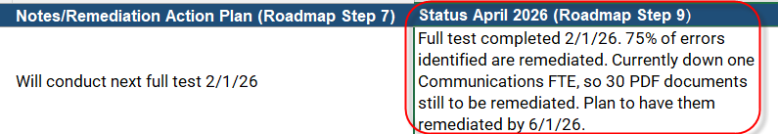

Figure 5: Example April 2026 status for Roadmap Step 9

**Once developed, you can send the updated agency audit spreadsheet to Missouri Assistive Technology -** [**info@mo-at.org**](mailto:info@mo-at.org) **by April 24, 2026.**

### Step 10: Submit your agency’s Digital Accessibility Plan

It has taken a lot of work to get to this point, but it is time to stop looking back at your existing content and start looking forward at how to manage your new content as it is created. This means drafting your agency’s Digital Accessibility Plan/Policy in accordance with Missouri’s state standard and Federal DOJ Title II. The Digital Accessibility Plan is an internal document that establishes controls necessary to ensure ongoing compliance with web accessibility requirements. You can find the agency [digital accessibility plan template here](https://at.mo.gov/wp-content/uploads/web-accessibility-plan-template-1.docx) to use and customize for your agency.

The plan includes items like:

* The State of Missouri’s Digital Accessibility Statement
* Agency’s Digital Accessibility Issue Resolution process
* Procurement of Accessible Digital Services procedures
* Accessibility Exclusions
* Staff Roles and Responsibilities
* Training Recommendations
* Testing Tools and Techniques

#### Agency Office Staff Required Training: Digital Accessibility Awareness/Document Accessibility Course

**Background**[The Missouri Employment First Act](https://revisor.mo.gov/main/OneSection.aspx?section=209.700) was enacted in August 2023. The act involves collaboration of state agencies that provide employment-related services or support to people with disabilities. This collaboration included drafting a Memorandum of Understanding (MOU) in 2025. This MOU includes a recommendation that all agencies require completion of a 20-30 minute “Web Accessibility Awareness/Document Accessibility” course for all agency office staff. This will be made available through MOVERS Learn by 6/30/25.

**Once drafted, the agency’s Digital Accessibility Plan must be submitted to** Missouri Assistive Technology - [info@mo-at.org](mailto:info@mo-at.org) **by April 24, 2026.**

## DEADLINE: On/After April 24, 2026

### Step 11: Maintain the accessibility of your content

As you can see, accessibility is a continuous process. Progress is not always a straight line and perfection is not expected. The key is to keep moving. That will demonstrate your commitment to an accessibility culture. You will need to constantly adapt and grow your agency’s web accessibility program to ensure any new content you create from here on out is accessible. As the program matures, accessibility won’t require extra time and effort because it’s integrated into daily tasks and decision-making processes.

1. **Fully integrate the digital accessibility plan into your organization**

* Now that you have developed your agency’s digital accessibility plan from Step 10, make sure to integrate the plan into your agency personnel policies, procedures, onboarding process and general communication. Establish a digital accessibility presence on your intranet and post your plan.

1. **Establish patterns for testing content**

* Test web content and documents for accessibility on a regular basis. Include this as a requirement in your agency’s Digital Accessibility plan at various points throughout the lifecycle of your content, such as: when a new website feature being developed; when new products are being evaluated for purchase or use; and when any web content or documents are being created/updated.
* Periodically review web and PDF accessibility reports within Siteimprove to make sure you are staying on track.
* Manually test high priority pages, features and forms yearly.

1. **Continue and expand accessibility training**

* It is important to keep learning about accessibility, especially as accessibility features and standards continue to change with technology. There are various accessibility training offerings on [MOVERS Learn](https://movers.mo.gov/movers), [LinkedIn Learning](http://www.linkedin.com/learning) and the [Missouri Assistive Technology YouTube Channel](https://youtube.com/playlist?list=PL3gdsTv-2beZh8yuRhm5rpQS6ypRzWAmJ&si=rAtpDREQh5dCEbdg). Expand knowledge on topics like [conduct an accessible meeting](https://at.mo.gov/ict-meetings/), [creating accessible complex images](https://at.mo.gov/ict-multimedia/#data-viz), or [learning about assistive technology](https://at.mo.gov/ict-users-tech/).

1. **Sign up for newsletters**

* Did you know that lots of accessibility organizations have newsletters? They are a great option for staying on top of what is going on in accessibility, and contain lots of tips, tricks, and trainings, too! Here are a few that may be helpful: [State of Missouri MO AT ICT Newsletter](https://docs.google.com/forms/d/e/1FAIpQLSf6-PGIjLEfiYkJLQQprzZ72wg8b8TPk4LXxGp_avhexpn9qQ/viewform); [A11y Weekly](https://a11yweekly.com/); [WebAIM Newsletter](https://webaim.org/newsletter/); [Minnesota IT Services Accessibility News](https://mn.gov/mnit/about-mnit/accessibility/news/); [Oklahoma ABLE Tech eNewsletter](https://www.okabletech.org/resources/publications/); [State of Colorado Web Accessibility Newsletter](https://oit.colorado.gov/accessibility/news).

1. **Periodically review and update your plan**

* Your agency digital accessibility plan is a living document and should be reviewed and updated on a regular basis (i.e., every other year).

1. Special thanks to Oklahoma ABLE Tech for “inventing the wheel” that became a main source for this roadmap!